System REQUIREMENTS SPECIFICATION
for
ECMS - MANIFEST

Release No 0.4 – June 2021

document identification no 3 char SYS ID/ DOC CODE /NN/ V M.n)  for details refer to document mgmt stds | document title | status  (draft/ released ) | date of release | pages
eCMS /SRS/01/V1.0 | System Requirement Specifications For eCMS Manifest | Draft | 08.2021

 | role in the project | Name | signature | date  (dd-mm-yy)
Authors | Technical Team | Shrinivas Udagatti  Alvin Ian P Paule  Ramoji Lokam  Shubham Sharma
Reviewers | Project Lead | Sujit Patra
Approver | Project Manager | Raghavan Jaganathan

Endorsement by System Owner (internal)
 | Name | designation | signature | date  (dd-mm-yy)
Endorsed by System Owner | Chiew Lan Tan | Senior Director

release history
Release Number | associated change request number | Date (mm,yyyy) | Brief Summary of changes | Author
1.0 |  | 08.2021

Table of Contents
Table of Contents 3
Introduction 4
A. Definitions and Abbreviations 4
B. References 6
1. Functional Requirements 7
1.1 Air Manifests 7
1.2 Road Manifests 40
1.2.1 Overview 40
1.2.2 Manifest Structure 40
1.2.3 Road Manifest Submission 40
1.2.4 Road Manifest Update 45
1.2.5 Road Manifest Cancellation 49
1.2.6 Gate-In Vehicle 52
1.2.7 Cancel Gate-In 54
1.3 Passenger Manifests 57
1.3.1 Overview 57
1.3.2 Manifest Structure 57
1.3.3 Passenger Manifest Submission 57
1.3.4 Update Passenger Manifest 61
1.3.5 Passenger Manifest Cancellation 65
1.4 Dispatch Challan 69
1.4.1 Overview 69
1.4.2 Assumptions and Restrictions 69
1.4.3 Dispatch Challan Notification 69
1.4.4 Dispatch Challan Process 70
1.4.5 Dispatch Challan Amendment 73
1.4.6 Gate-In Challan 77
1.5 Temporary Storage 80
1.5.1 Overview 80
1.5.2 Admit Goods into Temporary Storage 80
1.5.3 Release Goods from Temporary Storage 82
Appendix A 85
1. Configuration blueprint (CBP) 85
2. Air Manifest Upload files 85
3. Passenger manifest Integration file template 85
4. Manifest Printouts 85
5. Temporary Storage Tracking Details 86
6. Dispatch Challan Printout 86
7. Scheduler Jobs 86
8. User Interface 86

Introduction
This document defines & illustrates the business requirements, process flows as well as the detailed functional requirements of eCMS Manifest module to be implemented for Department of Revenue and Customs Bhutan.

Definitions and Abbreviations
The table below lists the different acronyms and abbreviations as well as the definitions used throughout this SRS.

S/N | Abbreviations | Description
 | ACT | Authorized Compliant Trader
 | AWB | Air Waybill
 | BACS | Bhutan Automated Customs System
 | BAFRA | Bhutan Agriculture and Food Regulatory Authority
 | BITS | Bhutan Integrated Tax System
 | BNB | Bhutan National Bank
 | BoB | Bank of Bhutan
 | BSTEC | Bhutan Sales Tax Exemption Certificate
 | BTC | Bhutan Tariff Classification
 | CAB | Customs Act of Bhutan
 | CDS | Customs Declaration System
 | CFA | Clearing and Forwarding Agent
 | CID | Citizens Identification Number
 | CIMP | Cargo Interchange Message Procedures
 | CRRB | Customs Rules and Regulations of Bhutan
 | DITT | Department of Information Technology & Telecom
 | DRC | Department of Revenue & Customs
 | eCMS | Electronic Customs Management System
 | EMS | Express Mail Service
 | ETA | Estimated Time of Arrival
 | ETD | Estimated Time of Departure
 | FRS | Functional Requirements Specification
 | GST | Goods and Services Tax
 | IATA | International Air Transport Association
 | IDEC | Import Duty Exemption Certificate
 | LCS | Land Customs Station
 | LoG | Letter of Guarantee
 | LTO | Liaison and Transit Office
 | MIS | Management Information System
 | MoEA | Ministry of Economic Affairs
 | MoF | Ministry of Finance
 | MoHCA | Ministry of Home and Cultural Affairs
 | Nu | Ngultrum
 | RAMIS | Revenue Administration Management Information System
 | RGoB | Royal Government of Bhutan
 | RMA | Royal Monetary Authority
 | RRCO | Regional Revenue and Customs Office
 | RTO | Regional Trade Office
 | SAD | Single Administration Document
 | SAARC | South Asian Association for Regional Cooperation
 | SCTS | Single Customs Trade System
 | SITA | International Aeronautical Telecommunications Society
 | TPN | Tax Payer Number
 | UPU | Universal Postal Union

References
The creation of the eCMS SRS was referenced using the following documents:
- FUNCATIONAL REQUIREMENT SPECIFICATION.docx
- TECHNICAL REQUIREMENT SPECIFICATION.docx
- Bhutan eCMS Technical Proposal TECH-3.pdf
- Bhutan eCMS Technical Proposal TECH-4.pdf
- Bhutan eCMS Technical Proposal TECH-5A.pdf
- Bhutan eCMS Technical Proposal TECH-5B.pdf
- Bhutan eCMS Technical Proposal TECH-6A.pdf
- Bhutan eCMS Technical Proposal TECH-6B.pdf

1. Functional Requirements

Air Manifests

Overview

Process ID: 03.01– Air manifest
Air manifest is submitted by Declarants and CFAs. Users manually create the manifest. Users can also mark air waybills as consolidated and assign the corresponding consolidating party.

Manifest Structure
The air manifest document is logically structured as shown in the below diagram:

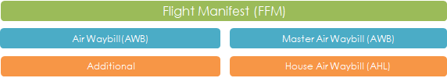

AIR MANIFEST STRUCTURE

The master manifest follows the IATA format. The master manifest comprises the CIMP FFM, the relationship to AWB (waybill) is 1-to-Many. The FFM indicates if the waybill is a master waybill or is consolidated (AHL). The containers in the AWB/AHL are not captured in the manifest.

Business Rules & User Group Access
For the business rules & user group access refer CBP document for Air manifests.

Shipment Type in Air Waybill
Following are the shipment types supported in the AWB processing. Samples are given
below:
Shipment
Shipment  Type | Flight Number | Air Waybill Number | No. of Packages | Remarks
Single | AB476 | AWB01 | 100 | All the Number of Packages comes with  one AWB and same flight.
Split | AB476 | AWB01 | 50 | Number of Packages will be split in the same manifest. one AWB, one Flight, split of No of Packages/pieces
 |  | AWB01 | 30
 |  | AWB01 | 20
Divide | AB476 | AWB01 | 50 | Combination of Split and Partial – No of Packages split  One AWB but in different  flights
 |  | AWB01 | 30
 | AB721 | AWB01 | 20
Partial | AB476 | AWB01 | 50 | The split of Number of Packages will come as parts in different flights.
 | AB721 | AWB01 | 30
ype

Air Manifest Submission
eCMS will enable the user to submit air master manifests through manual input/upload. eCMS will also enable a customs officer to approve the submission.

Pre-Requisites
- Users for submitting an Air Manifest should be a registered Declarant (or CFA) in eCMS.
- Customs officers for approving an Air Manifest should be a registered Customs officer in eCMS.
- Both Declarants and Custom officers are authorized to access eCMS and have access to the required application.
- Declarants who will be submitting consolidated AWBs already know which consolidator party assigned to the same AWB.
- User groups allowed to become consolidators of a master AWB have been configured.

Process Flow

Process ID: 03.01.01– Air manifest submission
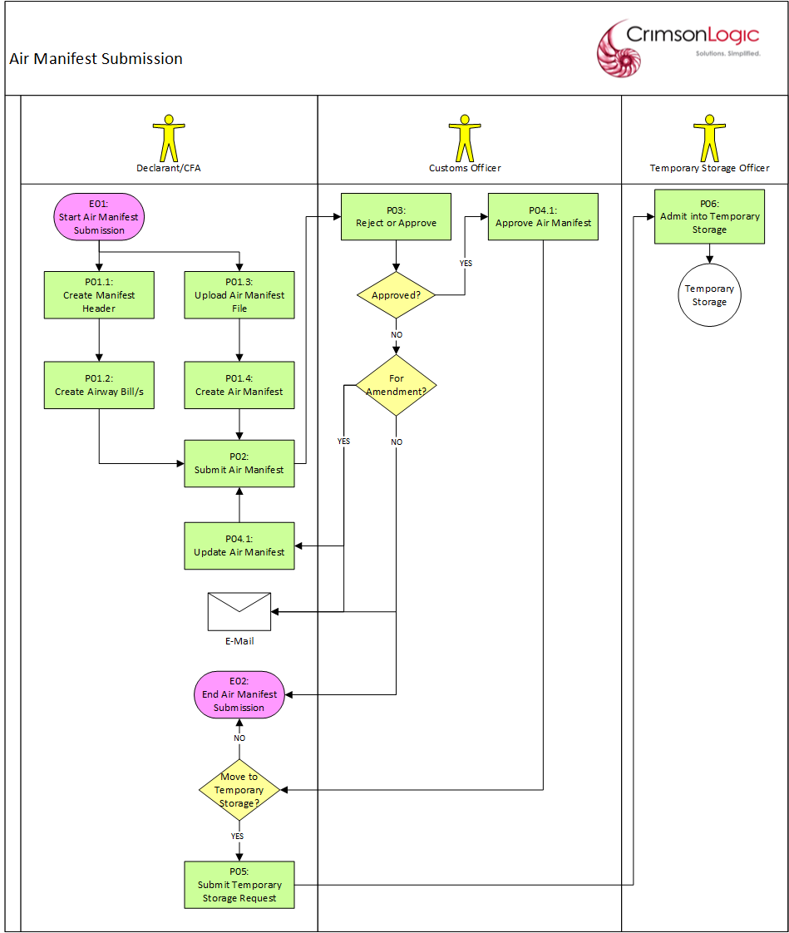

Process Steps
P01.1: Create Manifest Header
The user creates an air manifest starting with the header data. After entering all the mandatory inputs, the user can save the header data. But before allowing the header to be saved, the system will validate the inputs and will display messages if there are errors encountered. If there are no validation issues, the system will generate a unique Provisional Manifest Number and save the air manifest header with a Draft status.

The Provisional Manifest Number will have the following format:
PAM<DDMMYYYY######>

where:
DD – date
MM – month
YYYY – year
##### - running sequence number

P01.2: Create Air Waybill/s
The user can create air waybill/s only after the header data has been saved. The user can create as many AWBs in the system.

After entering all the mandatory inputs, the user can save the AWB data. But before allowing the AWB to be saved, the system will validate the inputs and will display messages if there are errors encountered. If there are no validation issues, the system will save the AWB.

Note/s:
- The AWB number should be assigned a reference value that is unique within the manifest.
- If the AWB type is Consolidated, then user must select a Consolidator Account Code from the list of Freight Forwarder/Clearing Agent parties and assign it to the AWB. The assigned Freight Forwarder can submit House Manifest and subsequent declaration.

P01.3: Upload Manifest File
The user can also create an air manifest by uploading a file in eCMS. The file format will be the one approved by DRC. The user uploads the file with minimal mandatory inputs. Only one manifest can be created per file upload.

After entering all the mandatory inputs, the user can save the air manifest file. But before allowing the file to be saved, the system will validate the inputs and file contents and will display messages if there are errors encountered. If there are no validation issues, the system will save the air manifest file and start processing its data.

P01.4: Create Air Manifest
After the system uploads the manifest file, the system will create and save the corresponding manifest header & AWBs with a Draft status. A unique Rotation Number and a Provisional Manifest Number will also be generated and saved along with the air manifest.

The Provisional Manifest Number will have the following format:
PAM<DDMMYYYY######>

where:
DD – date
MM – month
YYYY – year
##### - running sequence number

P02: Submit Air Manifest
The user submits the air manifest after creating the necessary AWBs. But before allowing the manifest to be submitted, the system will validate the manifest as a whole and will display messages if there are errors encountered.

If there are no validation issues, the system will submit the manifest with a Pending Approval status and will route the manifest to a customs officer for approval.

The customs officer who will receive the manifest will depend on the Customs Office that the user selected for the manifest.

Note/s:
- The number of AWBs created should be equal to the number of AWBs indicated in the manifest header.

P03: Reject or Approve
The manifest is routed to a customs officer for approval. The customs officer selects the manifest and determines which of the following statuses will be applied:
- Approve
- Reject for Amendments
- Reject

If the customs officer rejected the manifest/rejected the manifest for amendments, the user will be notified via email.

If the customs officer rejected the manifest, the user can submit a new Air Manifest afterwards to replace the rejected one.

If the customs officer rejected the manifest for amendments, the manifest will be routed back to the user for update and re-submission.

If the customs officer approves the manifest, the manifest and its AWBs will have an Approved status.

Note/s:
- A manifest will be auto-approved by customs (for all airports) if it has been configured to auto-approve a manifest.

P04.1: Update Air Manifest
After the request was rejected for amendments, the user updates the air manifest to correct the issues that caused its rejection.

If the user updates the manifest header and then tries to save, it will be subjected to the same validation process mentioned in P01.1.

If the user updates an AWB and then tries to save, it will be subjected to the same validation process mentioned in P01.2.

P04.2: Approve Air Manifest
After the customs officer approves the manifest, a unique Manifest Number will be assigned to the manifest. The AWBs can then be used for submitting declarations.

The Manifest Number will have the following format:
AMM<DDMMYYYY######>

where:
DD – date
MM – month
YYYY – year
###### - running sequence number

P05: Submit Temporary Storage Request
The user can choose to move the consignment to temporary storage by submitting a Temporary Storage Request. The system will save the request with a Pending Admittance status and the request will be routed to the temporary storage officer assigned to the storage the user selected.

P06: Admit into Temporary Storage
The temporary storage officer who receives the request will facilitate the actual movement of the consignment to the temporary storage. Once this has been completed, the request will be updated with an Admitted status.

If the temporary storage request is rejected, then the Declarant/CFA should submit the declaration using the AWB.

Use Case Diagram
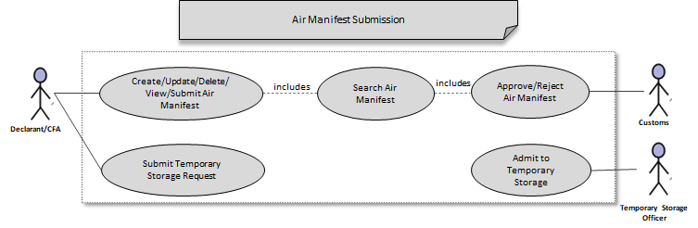
Note/s:
- A manifest in Draft status can be updated/deleted/submitted by any user of the same party that created the manifest or by a CFA.
- The list of consolidators can be configured as part of the registration process.

Business Validation

S/N | Validation Rules
1 | The AWB number should be assigned a reference value that is unique within the manifest.
2 | If the AWB type is Consolidated, then user must select a Consolidator Account Code from the list of Freight Forwarder/Clearing Agent parties and assign it to the AWB. The assigned Freight Forwarder can submit House Manifest and subsequent declaration.
3 | The number of AWBs created should be equal to the number of AWBs indicated in the manifest header.

Additional Air Manifest
eCMS will enable the user to add air waybills to an approved air master manifest through manual input/upload. eCMS will also enable a customs officer to approve the request.

Pre-Requisites
- Users for submitting an Additional Air Manifest should be a registered Declarant (or CFA) in eCMS.
- Customs officers for approving an Additional Air Manifest should be a registered Customs officer in eCMS.
- Both Declarants and Custom officers are authorized to access eCMS and have access to the required application.
- Declarants who will be submitting consolidated AWBs already know which consolidator party assigned to the same AWB.
- User groups allowed to become consolidators of a master AWB have been configured.

Process Flow

Process ID: 03.01.02 – Additional Air manifest
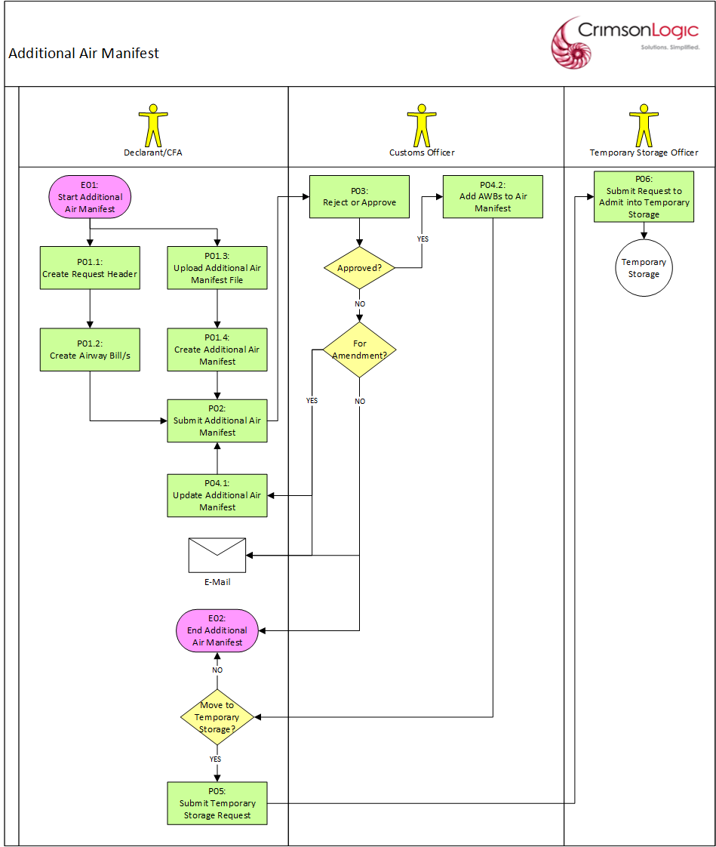

Process Steps
P01.1: Create Request Header
The user creates an additional air manifest starting with the request header. The user selects a manifest created by the user’s party and with an Approved status. Only one manifest can be selected for an additional air manifest request.

After entering all the mandatory inputs, the user can save the header data. But before allowing the header to be saved, the system will validate the inputs and will display messages if there are errors encountered. If there are no validation issues, the system will generate a unique Provisional Additional Manifest Number and save the request header with a Draft status.

The Provisional Additional Manifest Number will have the following format:
PAMA<DDMMYYYY######>

where:
DD – date
MM – month
YYYY – year
##### - running sequence number

P02: Create Air Waybill/s
The user can create additional air waybill/s only after the header data has been saved. The user can add as many AWBs the system.

After entering all the mandatory inputs, the user can save the AWB data. But before allowing the AWB to be saved, the system will validate the inputs and will display messages if there are errors encountered. If there are no validation issues, the system will save the AWB.

Note/s:
- The AWB number should be assigned a reference value that is unique within the manifest.
- If the AWB type is Consolidated, then user must select a Consolidator Account Code from the list of Freight Forwarder/Clearing Agent parties and assign it to the AWB. The assigned Freight Forwarder can submit the House Manifest and subsequent declaration.

P01.3: Upload Additional Air Manifest File
The user can also create an additional air manifest by uploading a file in eCMS. The file format will be the one approved by DRC. The user uploads the file with minimal mandatory inputs. The user can add in the upload file as many AWBs in the system.

After entering all the mandatory inputs, the user can save the additional air manifest file. But before allowing the file to be saved, the system will validate the inputs and file contents and will display messages if there are errors encountered. If there are no validation issues, the system will save the air manifest file and start processing its data.

P01.4: Create Additional Air Manifest
After the system uploads the manifest file, the system will create and save the corresponding additional air manifest header & AWBs with a Draft status. A unique Provisional Additional Manifest Number will also be generated and saved along with the additional air manifest. The Provisional Additional Manifest Number will also be displayed so that the user can use it to access the additional air manifest later and manually submit.

The Provisional Additional Manifest Number will have the following format:
PAM<DDMMYYYY######>

where:
DD – date
MM – month
YYYY – year
##### - running sequence number

P02: Submit Additional Air Manifest
The user submits the additional air manifest after creating the necessary AWBs. But before allowing the request to be submitted, the system will validate the request as a whole and will display messages if there are errors encountered.

If there are no validation issues, the system will submit the request with a Pending Approval status and will route the manifest to a customs officer for approval.

The customs officer who will receive the manifest will depend on the Customs Office that the user selected for the original air manifest.

Note/s:
- The number of AWBs created should be equal to the number of AWBs indicated in the request header.

P03: Reject or Approve
The manifest is routed to a customs officer for approval. The customs officer selects the request and determines which of the following statuses will be applied:
- Approve
- Reject for Amendments
- Reject

If the customs officer rejected the request/rejected the request for amendments, the user will be notified via email.

If the customs officer rejected the manifest, the user can submit a new Additional Air Manifest afterwards to replace the rejected one.

If the customs officer rejected the request for amendments, the request will be routed back to the user for update and re-submission.

If the customs officer approved the request, the request will have an Approved status.

P04.1: Update Additional Air Manifest
After the request was rejected for amendments, the user updates the additional air manifest to correct the issues that caused its rejection.

If the user updates the request header and then tries to save, it will be subjected to the same validation process mentioned in P01.1.

If the user updates an AWB and then tries to save, it will be subjected to the same validation process mentioned in P01.2.

P04.2: Add AWBs to Air Manifest
After the request has been approved, all the additional AWBs will become part of the original manifest and can be used for submitting declarations. A unique Additional Manifest Number will also be assigned to the request.

The Additional Manifest Number will have the following format:
AMA<DDMMYYYY######>

where:
DD – date
MM – month
YYYY – year
###### - running sequence number

P05: Submit Temporary Storage Request
The user can choose to move the consignment to temporary storage by submitting a Temporary Storage Request. The system will save the request with a Pending Admittance status and the request will be routed to the temporary storage officer assigned to the storage the user selected.

P06: Admit to Temporary Storage
The temporary storage officer who receives the request will facilitate the actual movement of the consignment to the temporary storage. Once this has been completed, the request will be updated with an Admitted status.

If the temporary storage request is rejected, then the Declarant/CFA should submit the declaration with the AWB.

Use Case Diagram

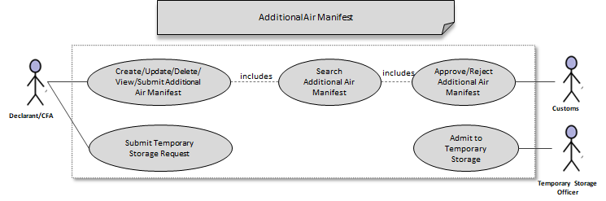
Note/s:
- A draft request can be updated/deleted/submitted by any user of the same party or by a CFA.
- The list of consolidators can be configured as part of the registration process.

Business Validation

S/N | Validation Rules
1 | The AWB number should be assigned a reference value that is unique within the manifest.
2 | If the AWB type is Consolidated, then user must select a Consolidator Account Code from the list of Freight Forwarder/Clearing Agent parties and assign it to the AWB. The assigned Freight Forwarder can submit House Manifest and subsequent declaration.
3 | The number of AWBs created should be equal to the number of AWBs indicated in the manifest header.

Air Manifest Amendment
eCMS will enable the user to amend an air waybill in an approved air master manifest through manual input. eCMS will also enable a customs officer to approve the request.

Pre-Requisites
- Users for submitting an Air Manifest Amendment should be a registered Declarant (or CFA) in eCMS.
- Customs officers for approving an Air Manifest Amendment should be a registered Customs officer in eCMS.
- Both Declarants and Custom officers are authorized to access eCMS and have access to the required application.
- Declarants who will be submitting consolidated AWBs already know which consolidator party assigned to the same AWB.
- User groups allowed to become consolidators of a master AWB have been configured.
- The air manifest should have already been approved by customs

Process Flow

Process ID: 03.01.03 – Air Manifest Amendment
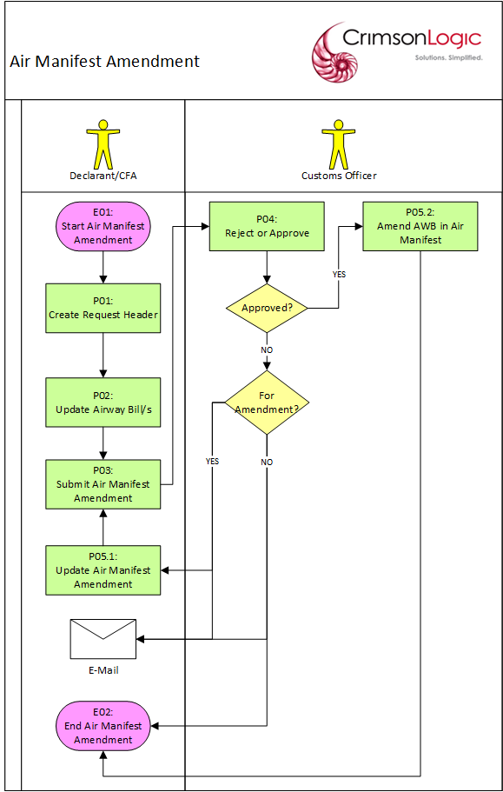

Process Steps
P01: Create Request Header
The user creates an air manifest amendment starting with the request header. The user selects a manifest created by the user’s party and with an Approved status. Only one air manifest can be selected for an air manifest amendment request.

Then the user must select at least one active AWB from the manifest selected earlier. An air waybill will be available for an amendment request if:
- it is not used in an active declaration
- it is a consolidated BL type has not yet been converted into a house manifest
- it is not used in another cancellation request that is pending approval
- it is not cancelled
- it is not used in another amendment request that is pending approval

Multiple AWBs can be included in an air manifest amendment request.

After entering all the mandatory inputs, the user can save the header data. But before allowing the header to be saved, the system will validate the inputs and will display messages if there are errors encountered. If there are no validation issues, the system will generate a Provisional Amendment Manifest Number and save the request header with a Draft status.

The Provisional Amendment Manifest Number will have the following format:
PAMA<DDMMYYYY######>

where:
DD – date
MM – month
YYYY – year
##### - running sequence number

Note/s:
- Once the request header has been saved, the selected air manifest number can no longer be changed.

P02: Update Air Waybill
The user can update the air waybill only after the header data has been saved.

After updating the inputs, the user can save the AWB data. But before allowing the AWB to be saved, the system will validate the inputs and will display messages if there are errors encountered. If there are no validation issues, the system will save the AWB updates.

Note/s:
- The AWB number cannot be updated.
- If the AWB type becomes Consolidated, then user must select a Consolidator Account Code from the list of Freight Forwarder/Clearing Agent parties and assign it to the AWB. The assigned Freight Forwarder can submit House Manifest and subsequent declaration.

P03: Submit Air Manifest Amendment
The user submits the air manifest amendment after saving the AWB updates. But before allowing the request to be submitted, the system will validate the request as a whole and will display messages if there are errors encountered.

If there are no validation issues, the system will submit the manifest with a Pending Approval status and will route the manifest to a customs officer for approval.

The customs officer who will receive the manifest will depend on the Customs Office that the user selected for the manifest.

P04: Reject or Approve
The request is routed to a customs officer for approval. The customs officer selects the request and determines which of the following statuses will be applied:
- Approve
- Reject for Amendments
- Reject

If the customs officer rejected the request for amendments, the user will be notified via email.

If the customs officer rejected the request, the user can submit a new Air Manifest Amendment afterwards to replace the rejected one.

If the customs officer rejected the request, the request will be routed back to the user for update and re-submission.

If the customs officer approves the request, the request will have an Approved status.

P05.1: Update Air Manifest Amendment
After the request was rejected for amendments, the user updates the air manifest amendment to correct the issues that caused its rejection.

If the user updates the request header and then tries to save, it will be subjected to the same validation process mentioned in P01.1.

If the user updates an AWB and then tries to save, it will be subjected to the same validation process mentioned in P01.2.

P05.2: Amend AWB in Air Manifest
After the customs officer approves the request, the AWB updates will take effect and will be in the current version of the AWB. A copy of the previous original values of the updated AWB will also be saved with a version number for audit purposes.

A unique Amendment Manifest Number will also be assigned to the request. The Amendment Manifest Number will have the following format:
AMA<DDMMYYYY######>

where:
DD – date
MM – month
YYYY – year
###### - running sequence number

Use Case Diagram

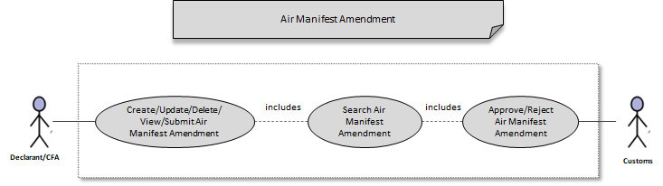

Note/s:
- A request in Draft status can be updated/deleted/submitted by any user of the same party that created the manifest or by a CFA.

Business Validation

S/N | Validation Rules
1 | An air waybill will be available for an amendment request if:  - it is not used in an active declaration  - it is a consolidated BL type has not yet been converted into a house manifest  - it is not used in another cancellation request that is pending approval  - it is not cancelled  - it is not used in another amendment request that is pending approval
2 | The AWB number cannot be updated.
3 | If the AWB type becomes Consolidated, then user must select a Consolidator Account Code from the list of Freight Forwarder/Clearing Agent parties and assign it to the AWB. The assigned Freight Forwarder can submit House Manifest and subsequent declaration.
4 | The number of AWBs created should be equal to the number of AWBs indicated in the manifest header.
5 | The AWB number should be assigned a reference value that is unique within the manifest.

Air Manifest Cancellation
eCMS will enable the user to cancel a manifest or one of its air waybills through manual input. eCMS will also enable a customs officer to approve the cancellation.

Pre-Requisites
- Users for submitting an Air Manifest cancellation should be a registered Declarant (or CFA) in eCMS.
- Customs officers for approving an Air Manifest cancellation should be a registered Customs officer in eCMS.
- Both Declarants and Custom officers are authorized to access eCMS and have access to the required application.
- The Air manifest submitted for cancellation has to be approved Air Manifest by customs
- Declarants who will be submitting consolidated AWBs already know which consolidator party assigned to the same AWB.
- User groups allowed to become consolidators of a master AWB have been configured

Process Flow

Process ID: 03.01.04 – Air Manifest Cancellation
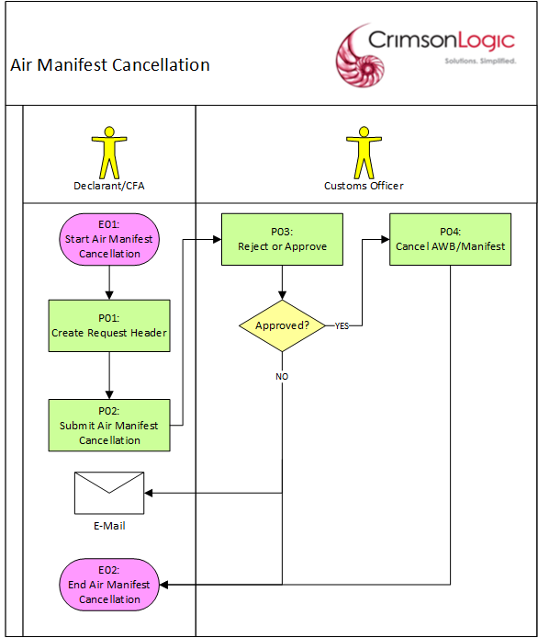

Process Steps
P01: Create Request Header
The user creates an air manifest cancellation starting with the request header. The user selects a manifest created by the user’s party and with an Approved status. Only one manifest can be selected for an air manifest cancellation request. Cancellation of multiple manifests is not recommended.

The user will choose the Manifest Cancellation type. If the cancellation type is Manifest type, then all the AWBs for the air manifest will be requested for cancellation. If the cancellation type is AWB Cancellation, then the user must select at least one active AWB from the manifest selected earlier. An air waybill will be available for a cancellation request if:
- it is not used in an active declaration
- it is a consolidated BL type has not yet been converted into a house manifest
- it is not used in another cancellation request that is pending approval
- it is not cancelled
- it is not used in another amendment request that is pending approval
- it is not in temporary storage
Multiple AWBs can be included in a AWB Cancellation-type request.

After entering all the mandatory inputs, the user can save the header data. But before allowing the header to be saved, the system will validate the inputs and will display messages if there are errors encountered. If there are no validation issues, the system will generate a Cancellation Manifest Number and save the request header with a Draft status.

The Cancellation Manifest Number will have the following format:
CNCL<DDMMYYYY######>

where:
DD – date
MM – month
YYYY – year
##### - running sequence number

P02: Submit Air Manifest Cancellation
The user submits the air manifest cancellation. If there are no validation issues, the system will submit the request with a Pending Approval status and will route the request to a customs officer for approval.

The customs officer who will receive the cancellation request depends on the Customs Office that the user selected for the original air manifest.

P03: Reject or Approve
The request is routed to a customs officer for approval. The customs officer selects the request and determines which of the following statuses will be applied:
- Approve
- Reject

If the customs officer rejected the request the user will be notified via email. The user can submit a new Air Manifest Cancellation afterwards to replace the rejected one.

If the customs officer approves the request, the request will have an Approved status.

P04: Cancel AWB/Manifest
After the request has been approved, the manifest/AWB in the request will have a Cancelled status. If a manifest has no approved AWB left after cancellation, then the manifest itself will have a Cancelled status.

Use Case Diagram

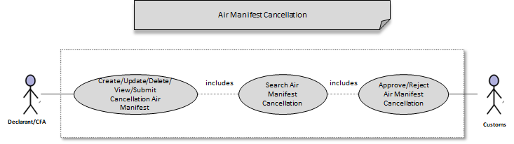

Note/s:
- A request in Draft status can be updated/deleted/submitted by any user of the same party that created the manifest or by a CFA.

Business Validation

S/N | Validation Rules
1 | An air waybill will be available for a cancellation request if:  - it is not used in an active declaration  - it is a consolidated BL type has not yet been converted into a house manifest  - it is not used in another cancellation request that is pending approval  - it is not cancelled  - it is not used in another amendment request that is pending approval  - it is not in temporary storage
2 | The AWB number cannot be updated.
3 | If the AWB type becomes Consolidated, then user must select a Consolidator Account Code from the list of Freight Forwarder/Clearing Agent parties and assign it to the AWB. The assigned Freight Forwarder can submit House Manifest and subsequent declaration.

Note/s:
- Please refer to Auto-Cancel AWB in Scheduler Jobs Section under Appendix for details regarding the batch job that auto-cancels AWB.

Air House Manifest Submission
eCMS will enable the user to select a consolidated air waybill that assigned to the user’s party and use it to create a house manifest. House manifests can be created through manual input/upload. eCMS will also enable a customs officer to approve the submission.

Pre-Requisites
- Users for submitting an Air House Manifest should be a registered Declarant (or CFA) in eCMS.
- Customs officers for approving an Air House Manifest should be a registered Customs officer in eCMS.
- Both Declarants and Custom officers are authorized to access eCMS and have access to the required application.
- The House manifest submitted for cancellation has to be approved Air Manifest by customs

Process Flow

Process ID: 03.01.05 – Air House Manifest Submission
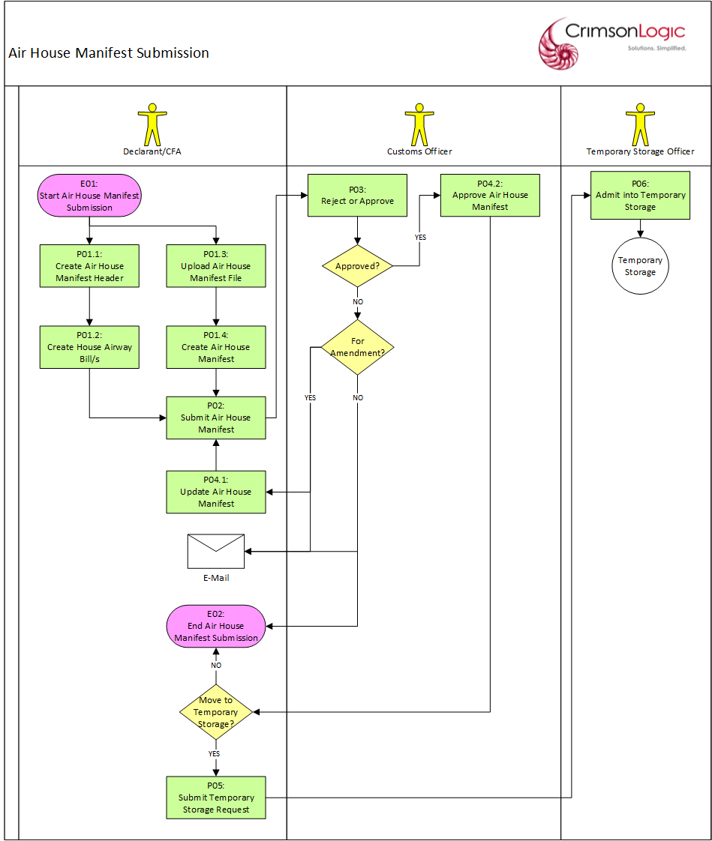

Process Steps
P01.1: Create House Manifest Header
The freight forwarder (also known as a consolidator) creates an air house manifest starting with the header data. The user selects a master air waybill and uses it to create a house manifest. The available master air waybills meet the following requirements:

- it should be assigned to the user’s party
- it is not used in another cancellation request that is pending approval
- it is not cancelled
- it is not used in another amendment request that is pending approval
- it is a consolidated BL type that is not yet converted into a house manifest
- it became partially deconsolidated because some of its house AWBs were cancelled or submitted by other party

After entering all the mandatory inputs, the user can save the header data. But before allowing the header to be saved, the system will validate the inputs and will display messages if there are errors encountered. If there are no validation issues, the system will generate a unique Provisional House Manifest Number and save the air house manifest header with a Draft status.

The Provisional House Manifest Number will have the following format:
PAH<DDMMYYYY######>

where:
DD – date
MM – month
YYYY – year
##### - running sequence number

Note/s:
- If the user is working with a house manifest that became partially deconsolidated, the existing house AWBs will be available for viewing only.

P01.2: Create House Air Waybill/s
The user can create house air waybill/s only after the header data has been saved. The user can create as many AWBs in the system if the total gross weight of the house AWBs is equal to the gross weight of the master air waybill.

After entering all the mandatory inputs, the user can save the house AWB data. But before allowing the AWB to be saved, the system will validate the inputs and will display messages if there are errors encountered. If there are no validation issues, the system will save the house AWB.

Note/s:
- The house AWB number should be assigned a reference value that is unique within the house manifest.
- Airway bills in a house manifest cannot be further consolidated. System will allow to create “Normal” House Manifest only.

P01.3: Upload Air House Manifest File
The user can also create an air house manifest by uploading a file in eCMS. The file format will be the one approved by DRC. The user uploads the file with minimal mandatory inputs. The user can include in the upload file as many house AWBs in the system if the total gross weight of the house AWBs is equal to the gross weight of the master air waybill.

After entering all the mandatory inputs, the user can save the air house manifest file. But before allowing the file to be saved, the system will validate the inputs and file contents and will display messages if there are errors encountered. With regards to the master air waybill selected for house manifest creation, it should meet the following requirements:

- it should be assigned to the user’s party
- it is not used in another cancellation request that is pending approval
- it is not cancelled
- it is not used in another amendment request that is pending approval
- it is a consolidated BL type that is not yet converted into a house manifest
- it became partially deconsolidated because some of its house AWBs were cancelled or submitted by other party

If there are no validation issues, the system will save the air house manifest file and start processing its data.

P01.4: Create Air House Manifest
After the system uploads the manifest file, the system will create and save the corresponding air house manifest header & house AWBs with a Draft status. A unique Provisional House Manifest Number will also be generated and saved along with the air house manifest. The Provisional House Manifest Number will also be displayed so that the user can use it to access the air house manifest later and manually submit.

The Provisional House Manifest Number will have the following format:
PAH<DDMMYYYY######>

where:
DD – date
MM – month
YYYY – year
##### - running sequence number

P02: Submit Air House Manifest
The user submits the air house manifest after creating the necessary AWBs. But before allowing the house manifest to be submitted, the system will validate the house manifest as a whole and will display messages if there are errors encountered.

If there are no validation issues, the system will submit the house manifest with a Pending Approval status and will route the house manifest to a customs officer for approval.

The customs officer who will receive the house manifest will depend on the Customs Office that the user selected for the master manifest.

Note/s:
- The number of the house AWBs created should be equal to the number of the house AWBs indicated in the house manifest header.
- The total gross weight of the house AWBs is equal to the gross weight of the master air waybill.

P03: Reject or Approve
The house manifest is routed to a customs officer for approval. The customs officer selects the manifest and determines which of the following statuses will be applied:
- Approve
- Reject for Amendments
- Reject

If the customs officer rejected the house manifest/rejected the manifest for amendments, the user will be notified via email.

If the customs officer rejected the house manifest for amendments, the house manifest will be routed back to the user for update and re-submission.

If the customs officer rejected the manifest, the user can submit a new Air House Manifest afterwards to replace the rejected one.

If the customs officer approved the house manifest, the house manifest and its AWBs will have an Approved status.

Note/s:
- A house manifest will be auto-approved by customs if its customs office has been configured to auto-approve a manifest.

P04.1: Update Air House Manifest
After the request was rejected for amendments, the user updates the air house manifest to correct the issues that caused its rejection.

If the user updates the house manifest header and then tries to save, it will be subjected to the same validation process mentioned in P01.1.

If the user updates a house AWB and then tries to save, it will be subjected to the same validation process mentioned in P01.2.

P04.2: Approve Air House Manifest
After the customs officer approved the house manifest, a unique House Manifest Number will be assigned to house the manifest. The house AWBs can then be used for submitting declarations.

The House Manifest Number will have the following format:
AMH<DDMMYYYY######>

where:
DD – date
MM – month
YYYY – year
###### - running sequence number

P05: Submit Temporary Storage Request
The user can choose to move the consignment to temporary storage by submitting a Temporary Storage Request. The system will save the request with a Pending Admittance status and the request will be routed to the temporary storage officer assigned to the storage the user selected.

P06: Admit into Temporary Storage
The temporary storage officer who receives the request will facilitate the actual movement of the consignment to the temporary storage. Once this has been completed, the request will be updated with an Admitted status.

If the temporary storage request is rejected, then the Declarant/CFA should now include the AWB in a declaration.

Use Case Diagram

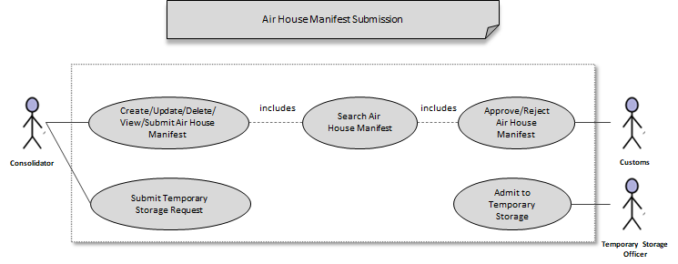

Notes:
- A house manifest in Draft status can be updated/deleted/submitted by any user of the same consolidator party.

Business Validation

S/N | Validation Rules
1 | The available master air waybills meet the following requirements:  - it should be assigned to the user’s party  - it is not used in another cancellation request that is pending approval  - it is not cancelled  - it is not used in another amendment request that is pending approval  - it is a consolidated BL type that is not yet converted into a house manifest  - it became partially deconsolidated because some of its house AWBs were cancelled or submitted by other party
2 | The total gross weight of the house AWBs is equal to the gross weight of the master air waybill.

Air House Manifest Amendment
eCMS will enable the user to amend an air waybill in an approved air house master manifest through manual input. eCMS will also enable a customs officer to approve the request.

Pre-Requisites
- Users for submitting an Air House Manifest Amendment should be a registered Declarant (or CFA) in eCMS and is the consolidator of the air house manifest.
- Customs officers for approving an Air House Manifest Amendment should be a registered Customs officer in eCMS.
- Both consolidator and Custom officers are authorized to access eCMS and have access to the required application.
- The house manifest submitted for amendment should be an approved house manifest by customs

Process Flow

Process ID: 03.01.06 – Air House Manifest Amendment
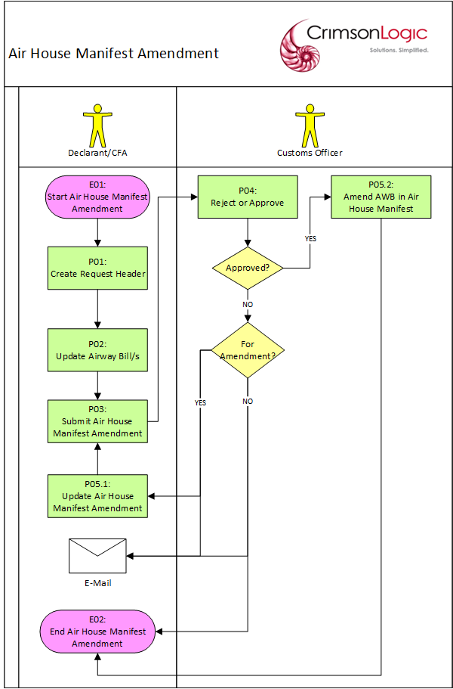

Process Steps
P01: Create Request Header
The user creates an air house manifest amendment starting with the request header. The user selects a s manifest created by the user’s party and with an Approved status. Only one house manifest can be selected for an air house manifest amendment request.

Then the user must select at least one active AWB from the house manifest selected earlier. An air waybill will be available for an amendment request if:
- it is not used in an active declaration
- it is not used in another cancellation request that is pending approval
- it is not cancelled
- it is not used in another amendment request that is pending approval
Multiple AWBs can be included in an air house manifest amendment request.

After entering all the mandatory inputs, the user can save the header data. But before allowing the header to be saved, the system will validate the inputs and will display messages if there are errors encountered. If there are no validation issues, the system will generate a Provisional Amendment Manifest Number and save the request header with a Draft status.

The Provisional Amendment Manifest Number will have the following format:
PAMA<DDMMYYYY######>

where:
DD – date
MM – month
YYYY – year
##### - running sequence number

Note/s:
- Once the request header has been saved, the selected house manifest number can no longer be changed.

P02: Update Air Waybill
The user can update the air waybill only after the header data has been saved.

After updating the inputs, the user can save the AWB data. But before allowing the AWB to be saved, the system will validate the inputs and will display messages if there are errors encountered. If there are no validation issues, the system will save the AWB updates.

Note/s:
- The AWB number cannot be updated.
- The total gross weight of the house AWBs should still be equal to the gross weight of the master air waybill.

P02: Submit Air House Manifest Amendment
The user submits the air house manifest amendment after saving the AWB updates. But before allowing the request to be submitted, the system will validate the manifest as a whole and will display messages if there are errors encountered.

If there are no validation issues, the system will submit the manifest with a Pending Approval status and will route the manifest to a customs officer for approval.

The customs officer who will receive the manifest will depend on the Customs Office that the user selected for the manifest.

P04: Reject or Approve
The request is routed to a customs officer for approval. The customs officer selects the request and determines which of the following statuses will be applied:
- Approve
- Reject for Amendments
- Reject

If the customs officer rejected the request for amendments, the user will be notified via email.

If the customs officer rejected the request, the user can submit a new Air Manifest Amendment afterwards to replace the rejected one.

If the customs officer rejected the request, the request will be routed back to the user for update and re-submission.

If the customs officer approves the request, the request will have an Approved status.

P05.1: Update Air House Manifest Amendment
After the request was rejected for amendments, the user updates the air house manifest amendment to correct the issues that caused its rejection.

If the user updates the request header and then tries to save, it will be subjected to the same validation process mentioned in P01.1.

If the user updates the AWB and then tries to save, it will be subjected to the same validation process mentioned in P01.2.

P05.2: Amend AWB in Air House Manifest
After the customs officer approves the request, the AWB updates will take effect and will be in the current version of the AWB. A copy of the previous original values of the updated AWB will also be saved with a version number for audit purposes.

A unique Amendment Manifest Number will also be assigned to the request.

The Amendment Manifest Number will have the following format:
AMA<DDMMYYYY######>

where:
DD – date
MM – month
YYYY – year
###### - running sequence number

Use Case Diagram

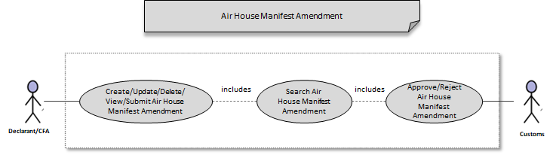

Note/s:
- A request in Draft status can be updated/deleted/submitted by any user of the same party that created the manifest or by a CFA.

Business Validation

S/N | Validation Rules
1 | An air waybill will be available for an amendment request if:  - it is not used in an active declaration  - it is not used in another cancellation request that is pending approval  - it is not cancelled  - it is not used in another amendment request that is pending approval
2 | The AWB number cannot be updated.
3 | The total gross weight of the house AWBs should still be equal to the gross weight of the master air waybill.

Air House Manifest Cancellation
eCMS will enable the user to cancel a house manifest or one of its air waybills through manual input. eCMS will also enable a customs officer to approve the cancellation.

Pre-Requisites
- Users for submitting an Air House Manifest cancellation should be a registered Declarant (or CFA) in eCMS.
- Customs officers for approving an Air House Manifest cancellation should be a registered Customs officer in eCMS.
- Both Declarants and Custom officers are authorized to access eCMS and have access to the required application.

Process Flow

Process ID: 03.01.07 – Air House Manifest Cancellation
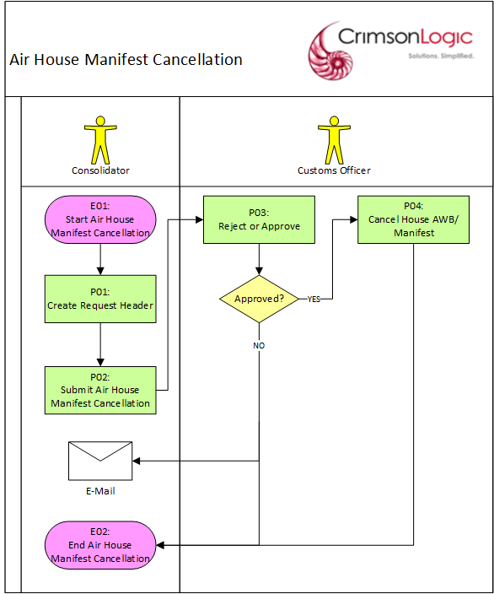

Process Steps
P01: Create Request Header
The user creates a cancellation air house manifest starting with the request header. The user selects a house manifest created by the user’s party and with an Approved status. Only one house manifest can be selected for a cancellation air house manifest request.

The user will choose the Manifest Cancellation type. If the cancellation type is Manifest type, then all the AWBs for the air house manifest will be requested for cancellation. If the cancellation type is AWB Cancellation, then the user must select at least one active AWB from the house manifest selected earlier. An air waybill will be available for a cancellation request if:
- it is not used in an active declaration
- it is not used in another cancellation request that is pending approval
- it is not cancelled
- it is not used in another amendment request that is pending approval
- it is not in temporary storage
Multiple AWBs can be included in a AWB Cancellation-type request.

After entering all the mandatory inputs, the user can save the header data. But before allowing the header to be saved, the system will validate the inputs and will display messages if there are errors encountered. If there are no validation issues, the system will generate a Cancellation Manifest Number and save the request header with a Draft status.

The Cancellation Manifest Number will have the following format:
CNCL<DDMMYYYY######>

where:
DD – date
MM – month
YYYY – year
##### - running sequence number

P02: Submit Air House Manifest Cancellation
The user submits the cancellation air house manifest. If there are no validation issues, the system will submit the request with a Pending Approval status and will route the request to a customs officer for approval.

The customs officer who will receive the request will depend on the Customs Office that the user selected for the original air manifest.

P03: Reject or Approve
The request is routed to a customs officer for approval. The customs officer selects the request and determines which of the following statuses will be applied:
- Approve
- Reject

If the customs officer rejected the request the user will be notified via email. The user can submit a new Air House Manifest Cancellation afterwards to replace the rejected one.

If the customs officer approved the request, the request will have an Approved status.

P04: Cancel House AWB/Manifest
After the request has been approved, the house manifest/AWB in the request will have a Cancelled status. If a manifest has no approved AWB left after cancellation, then the house manifest itself will have a Cancelled status.

If a house manifest has active house AWBs left after cancellation, then the master AWB will be available again for air house manifest creation, so that the consolidator can replace the house AWB that has been cancelled.

If a house manifest becomes cancelled, then the master AWB will be available again for air house manifest creation.

Use Case Diagram

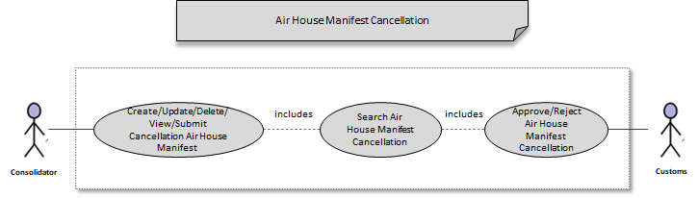

Business Validation

S/N | Validation Rules
1 | An air waybill will be available for a cancellation request if:  - it is not used in an active declaration  - it is not used in another cancellation request that is pending approval  - it is not cancelled  - it is not used in another amendment request that is pending approval  - it is not in temporary storage

Road Manifests

Overview

Process ID: 03.02 – Road Manifest
Road manifest is submitted by Declarants and CFAs. In road cargo, amendment can be done as well as cancellation.

Manifest Structure
The road manifest document is logically structured as shown in the below diagram:

ROAD MANIFEST STRUCTURE

The road manifest comprises a header and 1 or more invoices. The invoice is equivalent to the air waybill in the air manifest. The road manifest supports four types of cargo including
1) Containers
2) Bulk
3) Vehicles
4) and General Cargo

Only one type of cargo can be selected for an invoice. Separate invoices need to be created for manifests containing different types of cargo.

Road Manifest Submission
eCMS will enable the user to submit road manifests through manual input. eCMS will also enable a customs officer to approve the submission.

Pre-Requisites
- Users for submitting a Road Manifest should be a registered Declarant (or CFA) in eCMS.
- Customs officers for approving a Road Manifest should be a registered Customs officer in eCMS.
- Both Declarants and Custom officers are authorized to access eCMS and have access to the required application.

Process Flow

Process ID: 03.02.01– Road Manifest Submission
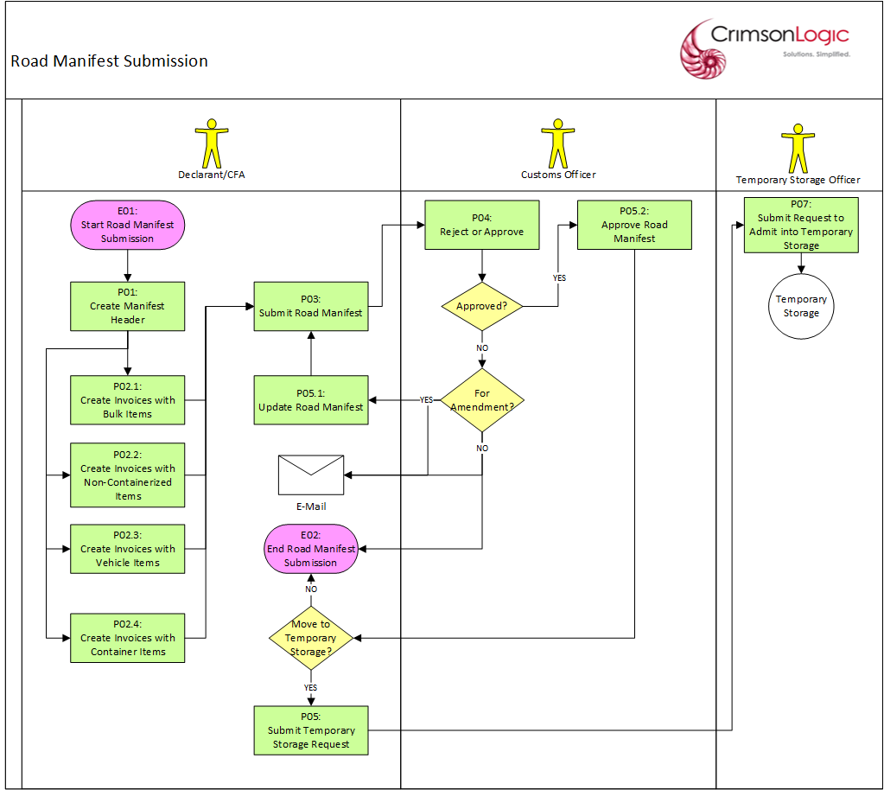

Process Steps
P01: Create Manifest Header
The user creates a road manifest starting with the header data. After entering all the mandatory inputs, the user can save the header data. But before allowing the header to be saved, the system will validate the inputs and will display messages if there are errors encountered. If there are no validation issues, the system will generate a unique Road Manifest Number and save the road manifest header with a Draft status.

The Road Manifest Number will have the following format:
RM<DDMMYYYY######>

where:
DD – date
MM – month
YYYY – year
##### - running sequence number

P02.1: Create Invoices with Bulk Items
The user can create invoices only after the header data has been saved. The user can create as many invoices as possible in the system.

For Invoices with bulk items, the user can choose the Bulk indicator. No other item types can be selected.

After entering all the mandatory inputs, the user can save the invoice data. But before allowing the invoice to be saved, the system will validate the inputs and will display messages if there are errors encountered. If there are no validation issues, the system will save the invoice.

Note/s:
- The Invoice number should be assigned a reference value that is unique within the manifest.

P02.2: Create Invoices with Non-Containerized Items
The user can create invoices only after the header data has been saved. The user can create as many invoices as possible in the system.

For Invoices with non-containerized items, the user can choose the non-Containerized indicator. No other item types can be selected.

After entering all the mandatory inputs, the user can save the invoice data. But before allowing the invoice to be saved, the system will validate the inputs and will display messages if there are errors encountered. If there are no validation issues, the system will save the invoice.

Note/s:
- The Invoice number should be assigned a reference value that is unique within the manifest.

P02.3: Create Invoices with Vehicle Items
The user can create invoices only after the header data has been saved. The user can create as many invoices as possible in the system.

For Invoices with vehicle items, the user can choose the Vehicle indicator. No other item types can be selected. Afterwards, the user must enter the number of vehicles to add and create the corresponding number of vehicle records.

After entering all the mandatory inputs, the user can save the invoice/vehicle data. But before allowing the invoice/vehicle to be saved, the system will validate the inputs and will display messages if there are errors encountered. If there are no validation issues, the system will save the invoice/vehicle record.

Note/s:
- The Invoice number should be assigned a reference value that is unique within the manifest.
- The chassis number of the vehicle should be unique within the manifest.

P02.4: Create Invoices with Container Items
The user can create invoices only after the header data has been saved. The user can create as many invoices as possible in the system.

For Invoices with container items, the user can choose the Container indicator. No other item types can be selected. Afterwards, the user must enter the number of containers to add and create the corresponding number of container records.

After entering all the mandatory inputs, the user can save the invoice/container data. But before allowing the invoice/container to be saved, the system will validate the inputs and will display messages if there are errors encountered. If there are no validation issues, the system will save the invoice/container record.

Note/s:
- The Invoice number should be assigned a reference value that is unique within the manifest.
- The container should be unique within the manifest.

P03: Submit Road Manifest
The user submits the road manifest after creating the necessary invoice/s and truck detail/s . But before allowing the manifest to be submitted, the system will validate the manifest as a whole and will display messages if there are errors encountered.

If there are no validation issues, the system will submit the manifest with a Pending Approval status and will route the manifest it to a customs officer for approval.

The customs officer who will receive the manifest will depend on the Customs Office that the user selected for the manifest.

Note/s:
- The number of invoices created should be equal to the number of invoices indicated in the manifest header.

P04: Reject or Approve
The manifest is routed to a customs officer for approval. The customs officer selects the manifest and determines which of the following statuses will be applied:
- Approve
- Reject for Amendments
- Reject

If the customs officer rejected the manifest/rejected the manifest for amendments, the user will be notified via email.

If the customs officer rejected the manifest, the user can submit a new Road Manifest afterwards to replace the rejected one.

If the customs officer rejected the manifest for amendments, the manifest will be routed back to the user for update and re-submission.

If the customs officer approved the manifest, the manifest and its invoices will have an Approved status.

Note/s:
- During approval, the customs officer will see all the vehicles with manifests that have not yet been approved/rejected. The customs officer will choose a vehicle and another screen will be displayed that will contain all the manifests associated with the vehicle. The customs officer can finally choose the manifest that has a pending approval status and do the approval.

- A manifest will be auto-approved by the system if its customs office has been configured to auto-approve a manifest.

P05.1: Update Road Manifest
After the request was rejected for amendments, the user updates the road manifest to correct the issues that caused its rejection.

If the user updates the manifest header and then tries to save it, it will be subjected to the same validation process mentioned in P01.

If the user updates an invoice and then tries to save it, it will be subjected to the same validation processes mentioned in P02.

P05.2: Approve Road Manifest
After the customs officer approves the manifest, the invoices can then be used to submit declarations.

P06: Submit Temporary Storage Request
The user can choose to move the consignment to temporary storage by submitting a Temporary Storage Request. The system will save the request with a Pending Admittance status and the request will be routed to the temporary storage officer assigned to the storage the user selected.

P07: Admit to Temporary Storage
The temporary storage officer who receives the request will facilitate the actual movement of the consignment to the temporary storage. Once this has been completed, the request will be updated with an Admitted status.

If the temporary storage request is rejected, then the Declarant/CFA should submit the declaration with the AWB.

Use Case Diagram

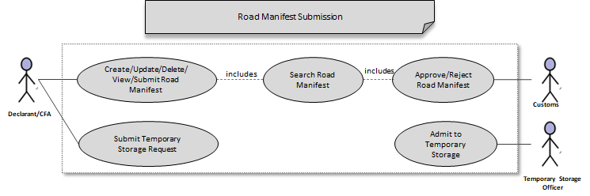

Note/s:
- A draft road manifest can be updated/deleted/submitted by any user of the same party or by a CFA.
- An invoice can be distributed into multiple manifests in case the invoice needs more than one vehicle for transport.
- One Road manifest can be linked to one declaration as a default. Multiple Road manifests can be linked to one declaration if they have the same importers.

Business Validation

S/N | Validation Rules
1 | The Invoice number should be assigned a reference value that is unique within the manifest.
2 | The chassis number of the vehicle should be unique within the manifest.
3 | The container should be unique within the manifest.
4 | The number of invoices created should be equal to the number of invoices indicated in the manifest header.

Update Road Manifest
eCMS will enable the user to update an approved road manifest through manual input.
eCMS will enable the user to amend the following the road manifest
- Add invoices
- Delete Invoices
- Amend vehicle details
- Amend driver’s details
- Accordingly, eCMS will also enable a customs officer to approve the request.

Pre-Requisites
- Users for submitting a Road Manifest Amendment should be a registered Declarant (or CFA) in eCMS.
- Customs officers for approving a Road Manifest Amendment should be a registered Customs officer in eCMS.
- Both Declarants and Custom officers are authorized to access eCMS and have access to the required application.
- The request for amendment, the road manifest should have been approved by customs

Process Flow

Process ID: 03.02.02 – Update Road Manifest
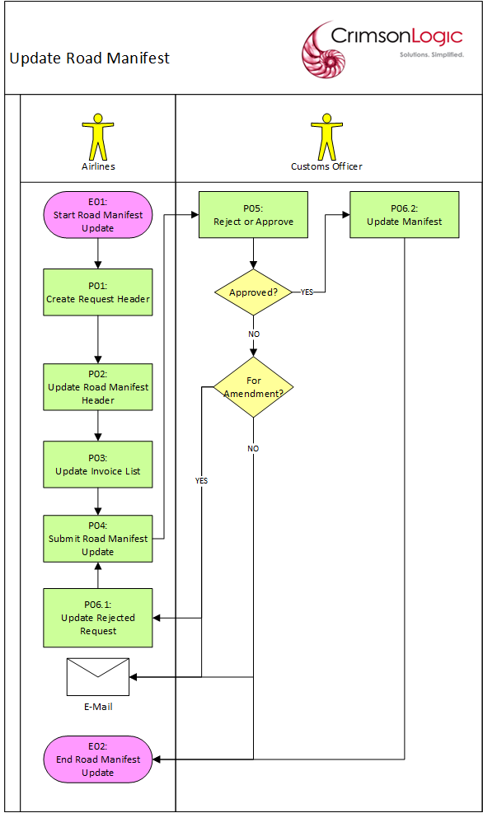

Process Steps
P01: Create Request Header
The user creates a road manifest amendment starting with the request header. The user selects a manifest created by the user’s party and with an Approved status. Only one manifest can be selected for a road manifest amendment request.

After selecting the manifest, the user can start updating Road Manifest header details except for the Rotation Number.

An invoice will be available for update/deletion if:
- it is not used/linked in an active declaration
- it is not used in another cancellation request that is pending approval
- it is not cancelled
- it is not used in another amendment request that is pending approval

Multiple invoices can be selected in a road manifest amendment request.

The system will allow amendment of the vehicle details as well as driver details.

After entering all the mandatory inputs, the user can save the header data. But before allowing the header to be saved, the system will validate the inputs and will display messages if there are errors encountered. If there are no validation issues, the system will generate a Provisional Amendment Manifest Number and save the request header with a Draft status.

The Provisional Amendment Manifest Number will have the following format:
PAMR<DDMMYYYY######>

where:
DD – date
MM – month
YYYY – year
##### - running sequence number

Note/s:
- Once the request header has been saved, the selected manifest number for update can no longer be changed.

P02: Update Road Manifest Header
The system will load the road manifest the user selected, and the user can update it. After updating all the editable inputs, the user can save them. But before allowing the details to be saved, the system will validate the inputs and will display messages if there are errors encountered. If there are no validation issues, the updates will be saved.

Note:
- Manifest Number cannot be updated.

P03: Update Invoice List
The system will load the invoice list of the manifest that the user selected. The user can then add/delete invoices from the invoice list or update invoice data in the list.

After updating all the editable inputs, the user can save them. But before allowing the details to be saved, the system will validate the inputs and will display messages if there are errors encountered. If there are no validation issues, the updates will be saved.

P04: Submit Road Manifest Update
The user submits the road manifest amendment after saving the invoice updates. But before allowing the request to be submitted, the system will validate the request as a whole and will display messages if there are errors encountered.

If there are no validation issues, the system will submit the manifest with a Pending Approval status and will route the manifest to a customs officer for approval.

The customs officer who will receive the manifest will depend on the Customs Office that the user selected for the manifest.

P05: Reject or Approve
The request is routed to a customs officer for approval. The customs officer selects the request and determines which of the following statuses will be applied:
- Approve
- Reject for Amendments
- Reject

If the customs officer rejected the request for amendments, the user will be notified via email.

If the customs officer rejected the request, the user can submit a new Road Manifest Amendment afterwards to replace the rejected one.

If the customs officer rejected the request, the request will be routed back to the user for update and re-submission.

If the customs officer approves the request, the request will have an Approved status.

P06.1: Update Rejected Manifest
After the request was rejected for amendments, the user updates the road manifest update to correct the issues that caused its rejection.

If the user updates the request header and then tries to save, it will be subjected to the same validation process mentioned in P02.

If the user updates an invoice and then tries to save, it will be subjected to the same validation process mentioned in P03.

P06.2: Update Manifest
After the customs officer approves the request, the updates will take effect and will be in the current version of the manifest. A copy of the previous original values of the updated manifest will also be saved with a version number for audit purposes.

A unique Amendment Manifest Number will also be assigned to the request. The Amendment Manifest Number will have the following format:
AMR<DDMMYYYY######>

where:
DD – date
MM – month
YYYY – year
###### - running sequence number

Use Case Diagram

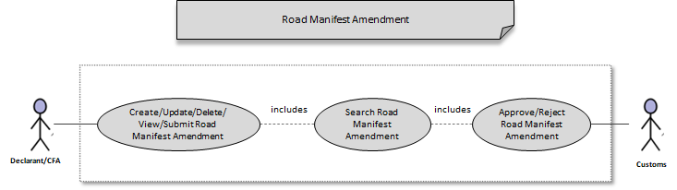

Note/s:
- A request in Draft status can be updated/deleted/submitted by any user of the same party that created the manifest or by a CFA.

Business Validation

S/N | Validation Rules
1 | An invoice will be available for an update request if:  - it is not used in an active declaration  - it is not used in another cancellation request that is pending approval  - it is not cancelled  - it is not used in another amendment request that is pending approval
2 | The manifest number cannot be updated.

Road Manifest Cancellation
eCMS will enable the user to cancel an approved road manifest. eCMS will also enable a customs officer to approve the cancellation.

Pre-Requisites
- Users for submitting a Road Manifest cancellation should be a registered Declarant (or CFA) in eCMS.
- Customs officers for approving a Rpad Manifest cancellation should be a registered Customs officer in eCMS.
- Both Declarants and Custom officers are authorized to access eCMS and have access to the required application.
- the road manifest submitted for cancellation has to be an approved road manifest.

Process Flow

Process ID: 03.02.03 – Road Manifest Cancellation
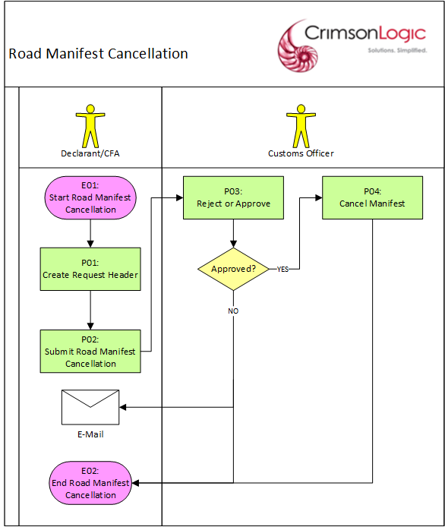

Process Steps
P01: Create Request Header
The user creates a road manifest cancellation starting with the request header. The user selects a manifest created by the user’s party and with an Approved status. Only one manifest can be selected for a road manifest cancellation request. A manifest can be selected for cancellation if:
- it is not used in an active declaration
- It is not yet included another cancellation request pending approval
- it is not cancelled
- it is not in temporary storage
- vehicle has not yet entered the country (no gate-in reference number)

After entering all the mandatory inputs, the user can save the header data. But before allowing the header to be saved, the system will validate the inputs and will display messages if there are errors encountered. If there are no validation issues, the system will generate a Cancellation Manifest Number and save the request header with a Draft status.

The Cancellation Manifest Number will have the following format:
CNCL<DDMMYYYY######>

where:
DD – date
MM – month
YYYY – year
##### - running sequence number

P02: Submit Road Manifest Cancellation
The user submits the road manifest cancellation. If there are no validation issues, the system will save the request with a Pending Approval status and will route the request to a customs officer for approval.

The customs officer who will receive the request will depend on the Customs Office that the user selected for the original road manifest.

P03: Reject or Approve
The request is routed to a customs officer for approval. The customs officer selects the request and determines which of the following statuses will be applied:
- Approve
- Reject

If the customs officer rejected the request the user will be notified via email. The user can submit a new Road Manifest Cancellation afterwards to replace the rejected one.

If the customs officer approved the request, the request will have an Approved status.

P04: Cancel Manifest
After the request has been approved, the manifest in the request will have a Cancelled status
The system will maintain the history of the record.

Use Case Diagram

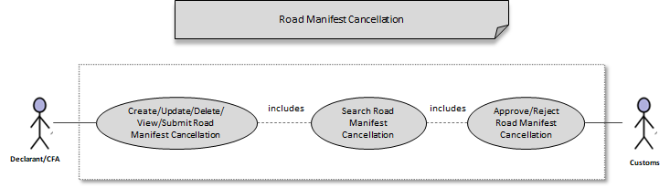

Note/s:
- Please refer to Auto-Cancel Invoice in Scheduler Jobs Section under Appendix for details regarding the batch job that auto-cancels invoices.

Business Validation

S/N | Validation Rules
1 | A manifest can be selected for cancellation if:  - it is not used in an active declaration  - It is not yet included another cancellation request pending approval  - it is not cancelled  - it is not in temporary storage  - vehicle has not yet entered the country (no gate-in reference number)

Gate-In Vehicle
eCMS will enable the customs officer to gate-in a vehicle along with selected vehicle registration number and manifest/s. This is to allow the customs officer to indicate which vehicle and the manifests that are included in the vehicle that is about to cross the border.

Pre-Requisites
- Customs officers for updating a vehicle for gate-in should be a registered Customs officer in eCMS.
- Custom officers are authorized to access eCMS and have access to the required application.

Process Flow

Process ID: 03.02.04 – Gate-in Vehicle
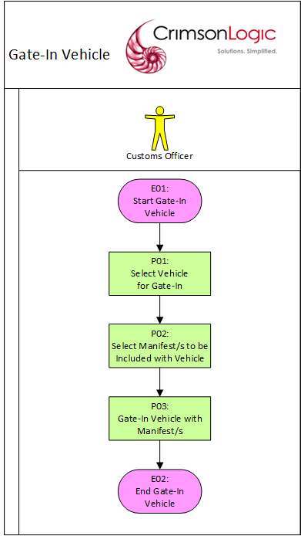

Process Steps
P01: Select Vehicle for Gate-In
The customs officer will be presented with a list of vehicles whose manifest are not included in a vehicle- that has crossed the border (or gate-in). Only one vehicle can be selected at a time for gate-in update.

P02: Select Manifest/s to be Included with Vehicle
After selecting a vehicle, the customs officer will be presented with a list of manifest/s that include the vehicle but have not yet been included in a gate-in. The list will be filtered to show the manifests whose ETA is today’s date. The customs officer must determine which manifest/s are included in the vehicle that is about to cross the border and select them. At least one manifest should be selected for gate-in.

Note:

- The system will automatically cancel those approved manifest that do not enter the country after 30 days from the date of approval.

P03: Gate-In Vehicle with Manifest/s
After selecting the manifest/s, the customs officer can update the vehicle status to Gate-In. A Gate-in timestamp and Gate-in Reference Number will be assigned to the vehicle and selected manifests.

Manifest/s that were included in the gate-in will no longer shown for gate-in purposes unless their gate-in status has been cancelled.

Use Case Diagram
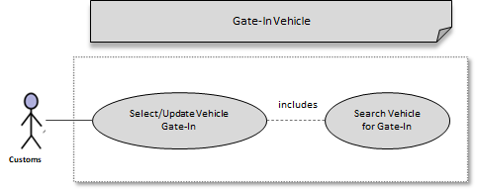

Business Validation

S/N | Validation Rules
1 | Manifest/s that were included in the gate-in will no longer shown for gate-in purposes unless their gate-in status has been cancelled.

Cancel Gate-In
eCMS will enable the customs officer to remove manifests that had been incorrectly included in a vehicle gate-in. This is since vehicles can have multiple manifests and some of them will be arriving at the border at different schedules. As an example, customs officer may have included a manifest in a vehicle that has crossed the border in the morning, only to find out that the manifest associated with the same vehicle will arrive at the border in the evening instead.

Pre-Requisites
- Customs officers for cancelling a vehicle gate-in should be a registered Customs officer in eCMS.
- Custom officers are authorized to access eCMS and have access to the required application.

Process Flow

Process ID: 03.02.05 – Cancel Gate-in
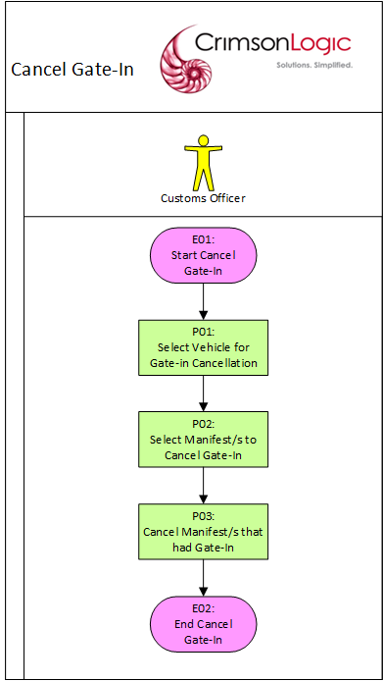
Process Steps
P01: Select Vehicle for Gate-in Cancellation
The customs officer will be presented with a list of vehicles whose manifest are included in a gate-in process. Only one vehicle can be selected at a time for gate-in update.

P02: Select Manifest/s to Cancel Gate-In
After selecting a vehicle, the customs officer will be presented with a list of manifest/s had been included in the vehicle’s gate-in. The customs officer must determine which manifest/s are not included in the vehicle that had crossed the border and select them. At least one manifest should be selected for gate-in cancellation.

P03: Cancel Manifest/s that had Gate-In
After selecting the manifest/s, the customs officer can clear the manifest’s Gate-In date and Gate-In reference number.

Manifest/s that were included in the gate-in cancellation will again show-up for gate-in purposes.

Use Case Diagram

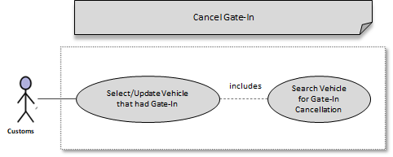

Business Validation

S/N | Validation Rules
1 | Manifest/s that were included in the gate-in cancellation will again show-up for gate-in purposes.

Passenger Manifests

Overview

Process ID: 03.03 – Passenger Manifest
Passenger manifest is submitted by airline operators. For passenger lists, amendment is done by replacement of the original manifest after cancellation. Likewise, supplementary is also done as replacement after cancellation of the original manifest.

Manifest Structure

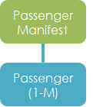

PASSENGER MANIFEST STRUCTURE

The passenger manifest comprises of a header and a list of passengers.

Passenger Manifest Submission
eCMS will enable the user to submit passenger manifests through manual input or upload. eCMS will also enable a customs officer to approve the submission.

Pre-Requisites
- Users for submitting a Passenger Manifest should be a registered Declarant (or CFA) in eCMS.
- Customs officers for approving a Passenger Manifest should be a registered Customs officer in eCMS.
- Both Declarants and Custom officers are authorized to access eCMS and have access to the required application.

Process Flow

Process ID: 03.03.01 – Passenger Manifest Submission
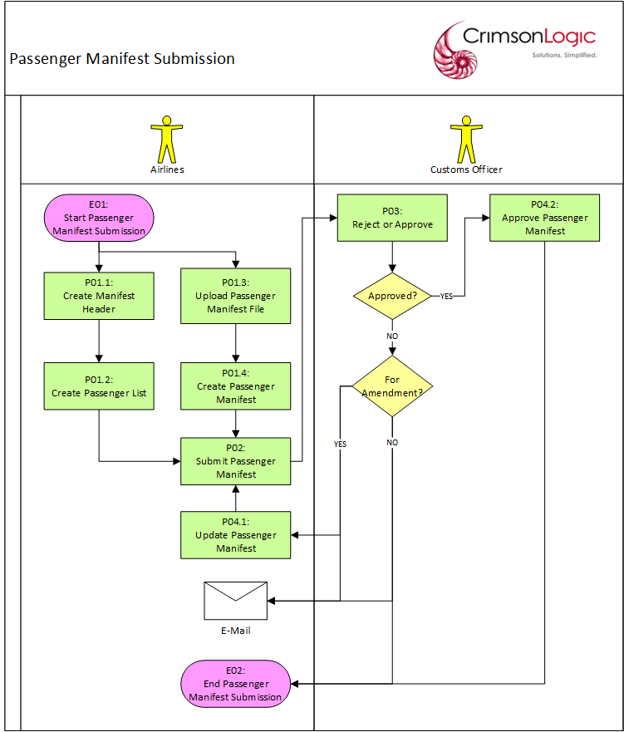

Process Steps
P01.1: Create Manifest Header
The user creates a passenger manifest starting with the header data. After entering all the mandatory inputs, the user can save the header data. But before allowing the header to be saved, the system will validate the inputs and will display messages if there are errors encountered. If there are no validation issues, the system will generate a unique Manifest Number and save the passenger manifest header with a Draft status.

The Manifest Number will have the following format:
XXX<DDMMYYYY######>

where:
XXX – Customs Site Code
DD – date
MM – month
YYYY – year
###### - running sequence number

P01.2: Create Passenger List
The user can create the passenger record only after the header data has been saved. The user can create as many passengers as possible in the system.

After entering all the mandatory inputs, the user can save the passenger data. But before allowing the passenger to be saved, the system will validate the inputs and will display messages if there are errors encountered. If there are no validation issues, the system will save the passenger record.

Note/s:
- The passport number should be unique within the manifest.

P01.3: Upload Passenger Manifest File
The user can also create a passenger manifest by uploading it as a file in eCMS. The file format will be the one approved by DRC.

After receiving the manifest, the system will validate the inputs and will respond with messages if there are errors encountered. If there are no validation issues, the system will respond with a success message and save the passenger manifest file and start processing its data.

P01.4: Create Passenger Manifest
After the system uploads the manifest file via system integration, the system will create and save the corresponding manifest header & passenger list with a Draft status. A unique Manifest Number will also be generated and will be displayed so that the user can use it to access the record later and manually submit.

The Manifest Number will have the following format:
XXX<DDMMYYYY######>

where:
XXX – Customs Site Code
DD – date
MM – month
YYYY – year
###### - running sequence number

P02: Submit Passenger Manifest
The user submits the passenger manifest after creating the necessary passenger records. But before allowing the manifest to be submitted, the system will validate the manifest as a whole and will display messages if there are errors encountered.

If there are no validation issues, the system will submit the manifest with a Pending Approval status and will route the manifest to a customs officer for approval.

The customs officer who will receive the manifest will depend on the Customs Office that the user selected for the manifest.

Note/s:
- The number of passengers created should be equal to the number of passengers indicated in the manifest header.

P03: Reject or Approve
The manifest is routed to a customs officer for approval. The customs officer selects the manifest and determines which of the following statuses will be applied:
- Approve
- Reject for Amendments
- Reject

If the customs officer rejected the manifest/rejected the manifest for amendments, the user will be notified via email.

If the customs officer rejected the manifest, the user can submit a new Passenger Manifest afterwards to replace the rejected one.

If the customs officer rejected the manifest for amendments, the manifest will be routed back to the user for update and re-submission.

If the customs officer approved the manifest, the manifest and passenger list will have an Approved status.

P04.1: Update Passenger Manifest
After the request was rejected for amendments, the user updates the passenger manifest to correct the issues that caused its rejection.

If the user updates the manifest header and then tries to save, it will be subjected to the same validation process mentioned in P01.1.

If the user updates a passenger and then tries to save, it will be subjected to the same validation process mentioned in P01.2.

P04.2: Approve Passenger Manifest
After the customs officer approved the manifest, the passenger manifest is no longer editable.

Use Case Diagram

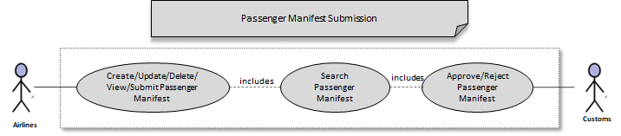

Notes:
- A draft passenger manifest can be updated/deleted/submitted by any operator of the same airline company.

Business Validation

S/N | Validation Rules
1 | The number of passengers created should be equal to the number of passengers indicated in the manifest header.

Update Passenger Manifest
eCMS will enable the user to update an approved passenger manifest through manual input. eCMS will also enable a customs officer to approve the submission. At the time of submission of an update request, the applicant can update the following but not limited to;
- Add/delete passenger from the manifest
- Edit passenger details in the manifest

Pre-Requisites
- Users for updating a Passenger Manifest should be a registered Declarant (or CFA) in eCMS.
- Customs officers for approving a Passenger Manifest update should be a registered Customs officer in eCMS.
- Both Declarants and Custom officers are authorized to access eCMS and have access to the required application.

Process Flow

Process ID: 03.03.02 – Update Passenger Manifest
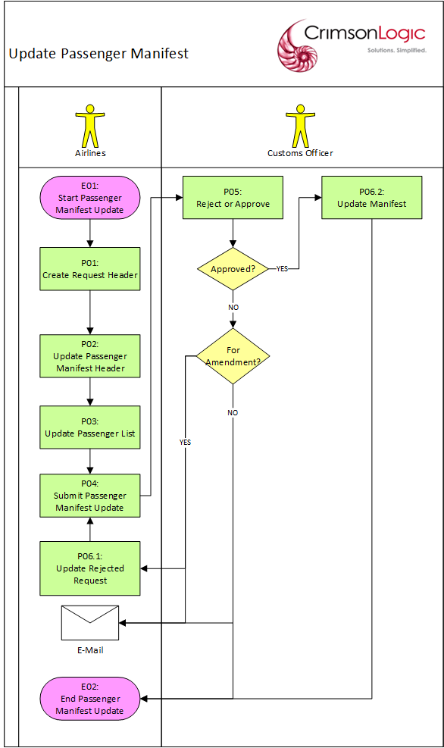

Process Steps
P01: Create Request Header
The user creates an update passenger manifest starting with the request header. The user selects a manifest created by the user’s party and with an Approved status. Only one manifest can be selected for an update passenger manifest request. A passenger manifest can be selected for update if:
- it is not used in another update request that is pending approval
- it is not used in another cancellation request that is pending approval
- it is not cancelled

After entering all the mandatory inputs, the user can save the request. But before allowing the request to be saved, the system will validate the inputs and will display messages if there are errors encountered. If there are no validation issues, the system will generate an Update Manifest Number and save the request header with a Draft status.

The Update Manifest Number will have the following format:
UPD<DDMMYYYY######>

where:
DD – date
MM – month
YYYY – year
##### - running sequence number

P02: Update Passenger Manifest Header
The system will load the passenger manifest the user selected and the user can update it. After updating all the editable inputs, the user can save them. But before allowing the details to be saved, the system will validate the inputs and will display messages if there are errors encountered. If there are no validation issues, the updates will be saved.

Note:
- Manifest Number cannot be updated.

P03: Update Passenger List
The system will load the passenger list of the manifest that the user selected. The user can then add/delete passengers from the passenger list or update passenger data in the list.

After updating all the editable inputs, the user can save them. But before allowing the details to be saved, the system will validate the inputs and will display messages if there are errors encountered. If there are no validation issues, the updates will be saved.

P04: Submit Passenger Manifest Update
The user submits the passenger manifest update. If there are no validation issues, the system will submit the request with a Pending Approval status and will route the request to a customs officer for approval.

The customs officer who will receive the request will depend on the Customs Office that the user selected for the original passenger manifest.

P05: Reject or Approve
The request is routed to a customs officer for approval. The customs officer selects the request and determines which of the following statuses will be applied:
- Approve
- Reject for Amendments
- Reject

If the customs officer rejected the request/rejected the request for amendments, the user will be notified via email.

If the customs officer rejected the manifest, the user can submit a new Update Passenger Manifest afterwards to replace the rejected one.

If the customs officer rejected the request for amendments, the request will be routed back to the user for update and re-submission.

If the customs officer approved the request, the request will have an Approved status.

P06.1: Update Rejected Request
After the request was rejected for amendments, the user updates the passenger manifest update request to correct the issues that caused its rejection.

If the user updates the request header and then tries to save it, it will be subjected to the same validation process mentioned in P02 and P03.

P06.2: Update Manifest
After the request has been approved, then only the updates will take effect in the passenger manifest.

Use Case Diagram

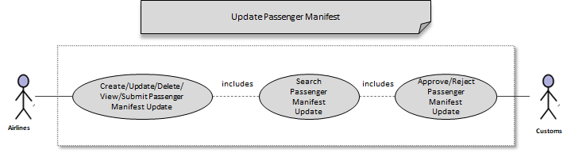

Notes:
- A draft request can be updated/deleted/submitted by any operator of the same airline company.

Business Validation

S/N | Validation Rules
1 | A passenger manifest can be selected for update if:  • it is not used in another update request that is pending approval  • it is not used in another cancellation request that is pending approval  • it is not cancelled
2 | The manifest number cannot be updated.

Passenger Manifest Cancellation
eCMS will enable the user to cancel an approved passenger manifest. eCMS will also enable a customs officer to approve the cancellation.

Pre-Requisites
- Users for cancelling a Passenger Manifest should be a registered Declarant (or CFA) in eCMS.
- Customs officers for approving a Passenger Manifest cancellation should be a registered Customs officer in eCMS.
- Both Declarants and Custom officers are authorized to access eCMS and have access to the required application.

Process Flow

Process ID: 03.03.03 – Passenger Manifest Cancellation
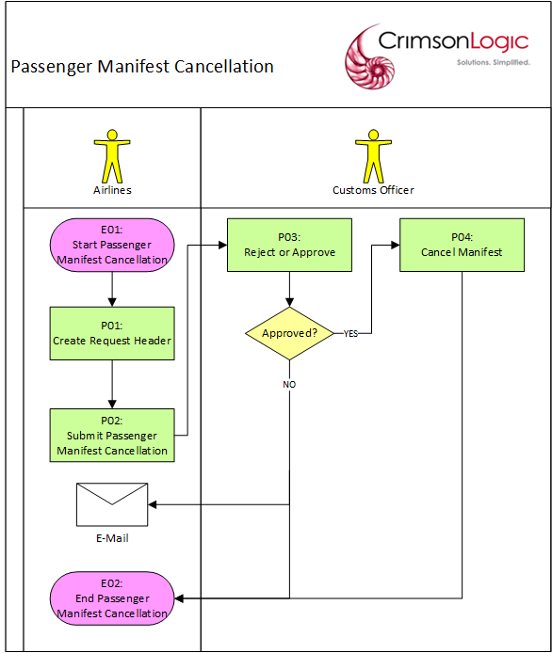

Process Steps
P01: Create Request Header
The user creates a passenger manifest cancellation starting with the request header. The user selects a manifest created by the user’s party and with an Approved status. Only one manifest can be selected for a passenger manifest cancellation request. A manifest can be selected for cancellation if:
- current date is not past the Estimated Arrival Time

After entering all the mandatory inputs, the user can save the header data. But before allowing the header to be saved, the system will validate the inputs and will display messages if there are errors encountered. If there are no validation issues, the system will generate a Cancellation Manifest Number and save the request header with a Draft status.

The Cancellation Manifest Number will have the following format:
CNCL<DDMMYYYY######>

where:
DD – date
MM – month
YYYY – year
##### - running sequence number

P02: Submit Passenger Manifest Cancellation
The user submits the passenger manifest cancellation. If there are no validation issues, the system will save the request with a Pending Approval status and will route the request to a customs officer for approval.

The customs officer who will receive the request will depend on the Customs Office that the user selected for the original passenger manifest.

P03: Reject or Approve
The request is routed to a customs officer for approval. The customs officer selects the request and determines which of the following statuses will be applied:
- Approve
- Reject

If the customs officer rejected the request the user will be notified via email. The user can submit a new Passenger Manifest Cancellation afterwards to replace the rejected one.

If the customs officer approved the request, the request will have an Approved status.

P04: Cancel Manifest
After the request has been approved, the manifest in the request will have a Cancelled status.
The system will maintain the history of the record.

Use Case Diagram
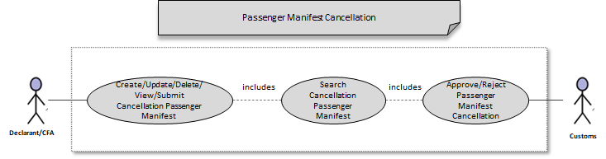

Business Validation

S/N | Validation Rules
1 | A manifest can be selected for cancellation if:  - It is not yet included another cancellation request pending approval  - it is not cancelled

Dispatch Challan

Overview

Process ID: 03.04 – Dispatch Challan
Dispatch Challan are required by Traders for Transportation of International Transit Declaration across the International boundary for entry into Bhutan. It serves twin purpose of authorization of transportation through the international boundary as well as for Gate in of the goods in Bhutan.

Post approval of the International Transit declaration and associated LOG (Letter of Guarantee), the declarant shall liaison with local Customs of the transiting country and procure the Bill of entry details. Subsequently, the declarant will submit a Dispatch challan for each International Transit declaration including amongst others,
- The Vehicle registration number of the transporting vehicle
- The approved International Transit declaration.
- The details of the driver of the vehicle

Upon submission of the dispatch Challan, the LTO office will review and approve the Challan. System will consolidate the approved dispatch Challan based on matching Vehicle number and date of departure and assign a unique Consolidated challan number. Once the LTO determines that all dispatch challans are consolidated, the LTO can take a print of the consolidated Challan and handover to the Transporter for transiting to Bhutan.

Assumptions and Restrictions
- Since multiple CFA’s can apply for dispatch challan for the same vehicle, therefore, after consolidation, the LTO shall generate the print of the Consolidated challan. This will control inadvertent printing of the consolidated Challan by the CFA before the consolidation could be completed.
- A dispatch challan can be linked to only one International Transit Declaration.
- The system will consolidate individual dispatch challan automatically at the vehicle level during customs approval.
- Consolidation will be done even if there is only one dispatch challan against the vehicle.
- It is assumed that a given vehicle engaged in transportation of international transit declaration cannot do multiple trips on the same day.
- Gate In at the Bhutan border shall be done at the Consolidated challan level. However, at the time of declaration the individual dispatch challan will be used
- Prints shall be generated only for the Consolidated dispatch challan. Prints are not required for individual dispatch challan.
- The international transit declaration instead of the dispatch challan will be used for temporary storage in LTO.

Dispatch Challan Notification
The system sends a notification through email at various stages of the dispatch challan processing. The events at which notification is sent is listed below.

Function | Notification
Rejection after submission | Declarant/Trader
Rejection for amendment | Declarant/Trader
Individual approval of manifest | Declarant/Trader
Approval along with Consolidation number | Declarant

Dispatch Challan Process
eCMS will enable the user to submit dispatch challans through manual input. eCMS will also enable a LTO officer to approve the submission.

Pre-Requisites
1. Associated International Transit declaration has been submitted and approved.
2. LOG associated with the international transit declaration has been submitted.
3. Declarant has coordinated with local Customs body of the transiting country and procured the Bill of entry details required as an input for the dispatch Challan.
4. Declarant has the correct and accurate vehicle details which will be engaged for transporting the consignments.
5. Declarant should be registered in the System and can access eCMS.
6. LTO Officers are registered and can access eCMS.

Process Flow

Process ID: 03.04.01 – Dispatch Challan Process
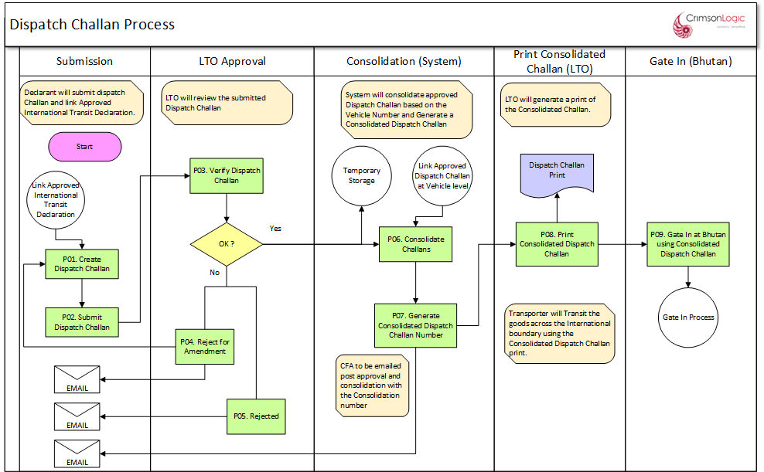

PROCESS STEPS
P01: Create Dispatch Challan
The declarant creates a dispatch challan and provides the following key inputs amongst others
- Approved International Transit Declaration.
- Vehicle number for transportation of goods.
- Drivers Details

Additionally, declarant will provide all required mandatory field and submit the dispatch challan.

P02: Submit Dispatch Challan
After submission of the dispatch challan, the challan shall be routed to the work queue of the next available Verifier at the LTO, on a rotational basis. If the Verifier is not available for any reason, Senior Verifiers must also be able to re-assign work assigned to Verifiers within their team.

P03: Verify Dispatch Challan
Verifier will verify the dispatch challan and ascertain that all details are provided correctly. The verifier will have the following options.
- Approve: In this case, the challan will be approved and routed for consolidation.
- Reject: In this case, the challan shall be rejected.
- Recommend for Amendment: In this case, the challan shall be routed back to declarant for amendment and re-submission.
In all cases, declarant shall be notified of the decision of LTO through email. In case of Rejection, reasons for rejection shall be communicated.

P04: Reject for amendment
If the Verifier determines that the challan needs to be amended, then the verifier can reject the challan for amendment. The challan shall be routed for Amendment. Declarant shall receive an email notification and can amend the challan and re-submit.

P05: Rejected
If the verifier determines that the challan needs to be rejected, then the verifier shall select reason for rejection and provide remarks. The challan shall be rejected, and no further actions are possible on the rejected challan. Declarant will be sent a notification on the rejection.

P06: Approval and Consolidation of Challans
If the verifier concludes that provided dispatch challan are correct, then the verifier can approve the dispatch challan.
Upon approval of the dispatch challan, system will consolidate the approved dispatch challan with previously approved dispatch challan sharing the same vehicle registration number. A unique consolidation number shall be generated which will link all related dispatch challan which share the same vehicle number.
After completion of consolidation, the CFA shall be informed on the approval and consolidation number through email.

System shall also offer the following
- Consolidation number will be shown to the CFA alongside the dispatch challan in the CFA view of dispatch challan.
- LTO can search and view Consolidation details of all dispatch challans through a consolidated challan search and view interface.

P07: Generate consolidated dispatch challan number
During consolidation of dispatch challan, system will generate a unique consolidation number for the consolidation at the vehicle registration number level. Future approved dispatch challan for the same vehicle number shall be consolidated under the consolidation number already generated for the vehicle.

Once a consolidation number for a vehicle has been generated, it shall be used for all consolidation against the vehicle until the vehicle completes gate-out from LTO. Once the vehicle gates out from LTO the consolidation number shall be deemed as closed and the system will not allow any further consolidation of dispatch challan. Future dispatch challans against the same vehicle will have a new consolidation number.

P08: Print dispatch challan number
After consolidation, LTO can generate a print of the consolidated dispatch challan.

P09: Gate in in Bhutan using consolidated dispatch challan number
A Gate officer at Bhutan port can Gate in using the consolidated dispatch challan. Upon completion of Gate in, the consolidation shall be considered as closed. Additional process for Gate in is covered separately under Gate In process for Dispatch challan.

Use Case Diagram

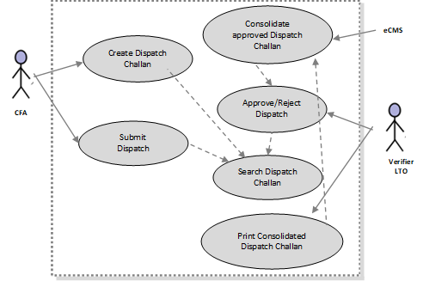

Note/s:
- A draft dispatch can be updated/deleted/submitted by any user of the same party or by a CFA.

Business Validation

S/N | Validation Rules
1 | The CFA can only view dispatch challan created by them.
2 | CFA will need to link an approved international transit declaration which was submitted by the same CFA.
3 | An international transit declaration can be linked to only one dispatch challan.
4 | A dispatch challan can have only one international transit declaration.
5 | The consolidated dispatch challan will have multiple international transit declaration
6 | After gate-out from the LTO, future dispatch challan will not be consolidated under the same and any dispatch challan submitted for the same vehicle will have a new consolidation.
7 | Before Gate out from LTO, all dispatch challan approved for a vehicle will share the same consolidation number.  Example:  - One vehicle, one declaration and single CFA  - One vehicle, multiple declarations and single CFA  - One vehicle, multiple declarations and multiple CFA  Note : CFA has to choose if they are sharing the transport vehicle during the international transit.
8 | In case one declaration and one CFA required multiple vehicles to transport, CFA has to submit multiple dispatch challan.
9 | The dispatch challan should have at least one declaration linked to it.
10 | The consolidated challan can have at least one dispatch challan linked to it.

Dispatch Challan Amendment
eCMS will enable the user to amend an approved dispatch challan through manual input. eCMS will also enable a LTO officer to approve the request.

Pre-Requisites
- Users for submitting a Dispatch Challan Amendment should be a registered Declarant (or CFA) in eCMS.
- LTO officers for approving a Dispatch Challan Amendment should be a registered Customs officer in eCMS.
- Both Declarants and LTO officers are authorized to access eCMS and have access to the required application.

Process Flow

Process ID: 03.04.02 – Dispatch Challan Amendment
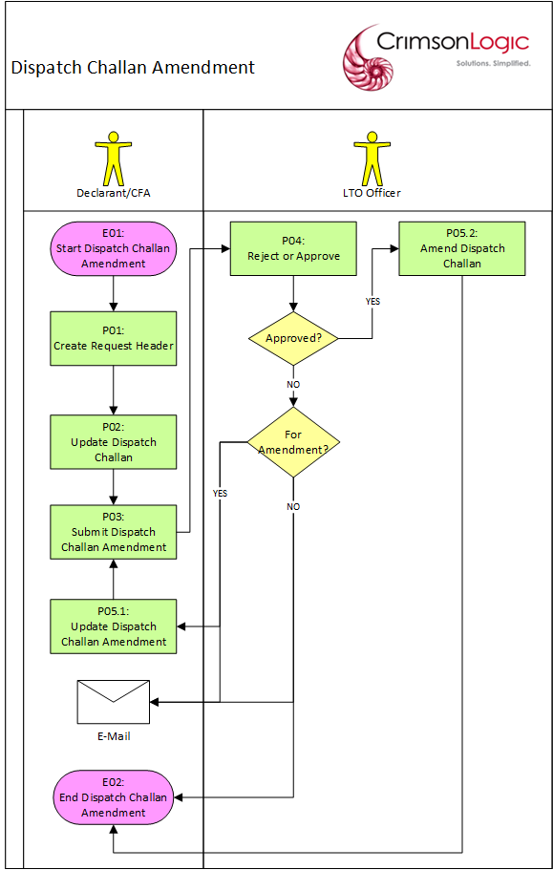

Process Steps
P01.1: Create Request Header
The user creates a dispatch challan amendment request starting with the request header. The user selects a dispatch challan created by the user’s party and with an Approved status. A dispatch challan will be available for an amendment request if:
- the international transit declaration in the dispatch challan has not gated out (LTO).
- it is not used in another amendment request that is pending approval
- the amendment for the details of vehicle and driver will be allowed, after gate-out (LTO) and before gate-in (Bhutan).

After entering all the mandatory inputs, the user can save the header data. But before allowing the header to be saved, the system will validate the inputs and will display messages if there are errors encountered. If there are no validation issues, the system will generate a Provisional Amendment Dispatch Challan Number and save the request header with a Draft status.

The Provisional Amendment Dispatch Challan Number will have the following format:
PCHR<DDMMYYYY######>

where:
DD – date
MM – month
YYYY – year
##### - running sequence number

Note/s:
- Once the request header has been saved, the selected dispatch challan can no longer be changed.

P01.2: Update Dispatch Challan
The user can update the dispatch challan only after the header data has been saved.

After updating the inputs, the user can save the challan data. But before allowing the challan to be saved, the system will validate the inputs and will display messages if there are errors encountered. If there are no validation issues, the system will save the updates.

Note/s:
- The dispatch challan number cannot be updated.

P02: Submit Dispatch Challan Amendment
The user submits the dispatch challan amendment after saving the updates. But before allowing the request to be submitted, the system will validate the request as a whole and will display messages if there are errors encountered.

If there are no validation issues, the system will submit the manifest with a Pending Approval status and will route the manifest to a customs officer for approval.

The customs officer who will receive the manifest will depend on the Customs Office that the user selected for the manifest.

P03: Reject or Approve
The request is routed to a customs officer for approval. The customs officer selects the request and determines which of the following statuses will be applied:
- Approve
- Reject for Amendments
- Reject

If the customs officer rejected the request for amendments, the user will be notified via email.

If the customs officer rejected the request, the user can submit a new Road Manifest Amendment afterwards to replace the rejected one.

If the customs officer rejected the request, the request will be routed back to the user for update and re-submission.

If the customs officer approves the request, the request will have an Approved status.

P04.1: Update Dispatch Challan Amendment
After the request was rejected for amendments, the user updates the road manifest amendment to correct the issues that caused its rejection.

If the user updates the request header and then tries to save, it will be subjected to the same validation process mentioned in P01.1.

If the user updates an invoice and then tries to save, it will be subjected to the same validation process mentioned in P01.2.

P04.2: Amend Dispatch Challan
After the customs officer approves the request, the dispatch challan updates will take effect and will be in the current version of the dispatch challan. A copy of the previous original values of the updated dispatch challan will also be saved with a version number for audit purposes.

A unique Amendment Dispatch Challan Number will also be assigned to the request. The Amendment Dispatch Challan Number will have the following format:
ACHR<DDMMYYYY######>

where:
DD – date
MM – month
YYYY – year
###### - running sequence number

Use Case Diagram

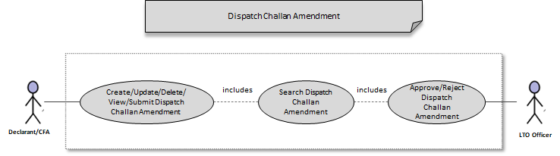

Note/s:
- A request in Draft status can be updated/deleted/submitted by any user of the same party that created the amendment request or by a CFA.
- In case of multiple CFA uses same vehicle, during breakdown either one of the CFA could update the vehicle and driver details.

Business Validation

S/N | Validation Rules
1 | An approved individual dispatch challan will be available for an amendment request if:  - the international transit declaration in the dispatch challan has not yet cleared the first port i.e. not yet gated out (LTO).  - it is not used in another amendment request that is pending approval  - the amendment for the details of vehicle and driver will be allowed, after gate-out (LTO) and before gate-in (Bhutan).  However, the system will not allow consolidation of individual manifest after the same has been released from the port of exit (LTO)

Gate-In Challan
eCMS will enable the customs officer to gate-in a consolidated challan along with the declarations (international transits declaration) linked to it. This is to allow the customs officer to indicate which dispatch challan/s registered under a particular vehicle that is about to cross the border.

Pre-Requisites
- Customs officers for updating a consolidated challan for gate-in should be a registered Customs officer in eCMS.
- Custom officers are authorized to access eCMS and have access to the required application.

Process Flow

Process ID: 03.04.03 – Gate-in Challan
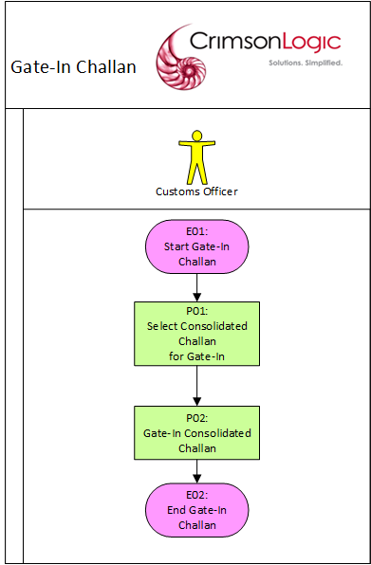

Process Steps
P01: Select Consolidated Challan for Gate-In
The customs officer will be presented with a list of consolidated challan whose vehicle have not yet crossed the border (or gated-in). Only one consolidated challan can be selected at a time for gate-in update.

P02: Gate-In Consolidated Challan
After selecting a vehicle, the customs officer will be presented with a list of declarations linked to the consolidated challan. The customs officer can then update the consolidated challan’s status to Gate-In. A Gate-in timestamp and Gate-in Reference Number will be assigned to the consolidated challan.

Once a consolidated challan has gated-in, the vehicle will be available for new dispatch challan.

Use Case Diagram
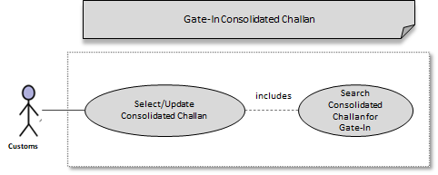

Business Validation

S/N | Validation Rules
1 | The vehicle will be available again for dispatch challan once it has gate-in in Bhutan.

Temporary Storage

Overview

Process ID: 03.05 – Temporary Storage
Goods that arrive by Air transport (AWB), Road (Manifest Invoice) the declarant/CFA must submit separate request to admit into temporary storage after the Air/Road manifest or Dispatch Challan has been approved.

Admit Goods into Temporary Storage
The process of admitting the goods into the Temporary Storage starts once the manifest/dispatch challan is submitted and approved and moved the consignment into temporary storage by submitting a Temporary Storage Request. The system will save the request with a Pending Admittance status and the request will be routed to the temporary storage operator assigned to the storage.

Pre-Requisites
Declarant/CFA must be submitting an entry request to temporary storage before admitting into Temporary Storage.

Process Flow

Process ID: 03.05.01 – Goods Admittance to Temporary Storage
Start Admit
End Admit

Process Steps
P01: Submit Temporary Storage Request
Once the CFA submitted the request to admit manifest into temporary storage which they were importing for home use, the manifest can be seen by the concerned temporary Storage Operator for admission of the goods into the temporary storage.

Note/s:
An air waybill/invoice will be available for a temporary storage request if:
- it is not used in an active declaration (for invoice/air waybill)
- it is not a consolidated BL type (for air waybills)
- it is not used in another cancellation request that is pending approval (for invoice/air waybill)
- it is not used in another amendment request that is pending approval
- it is not cancelled (for invoice/air waybill)
- it is not in temporary storage

P02: Admit to Temporary Storage
The temporary storage operator will process the request and facilitate the actual movement of the consignment to the temporary storage. Once this has been completed, the request will be updated with an Admitted status.

Use Case Diagram

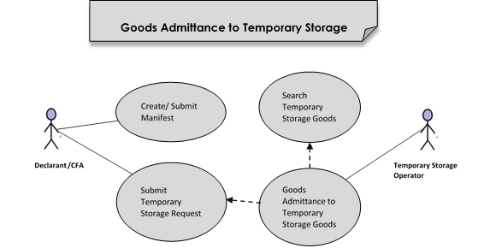

Business Validation

S/N | Validation Rules
1 | An air waybill/invoice details will be available for a temporary storage request if:  - it is not used in an active declaration (for invoice/air waybill)  - it is not a consolidated BL type (for air waybills)  - it is not used in another cancellation request that is pending approval (for invoice/air waybill)  - it is not used in another amendment request that is pending approval  - it is not cancelled (for invoice/air waybill)  - it is not in temporary storage
2 | The temporary storage officer can only admit goods that have been requested for the temporary storage assigned to the officer.

Release Goods from Temporary Storage
The process of releasing the goods from the Temporary Storage starts after the Clearance process (i.e., Release Cargo) of the declarations

Pre-Requisites
Declaration must be submitted, duties are paid and completed the customs clearance process.

Process Flow

Process ID: 03.05.02 – Goods Release from Temporary Storage
End Release
Start Release

Process Steps
P01: Calculate Storage Fees
Declarants need to create and submit import declaration and calculate the charges based on goods can only remain in temporary storage for up to seven (7) working days. After seven (7) working days, the goods have not removed from temporary storage, then storage charges will be applied for each day up to a maximum of fifteen (15) working days.

P02: Release from Temporary Storage
Once the release officer released the goods in the import declaration/temporary admission/warehouse, national transit, the approved declaration can be seen by the concerned Temporary Storage Operator for release of the goods from the Temporary Storage. The goods/items of the Import declaration are released from the Temporary Storage by the Temporary Storage Operator.

Use Case Diagram

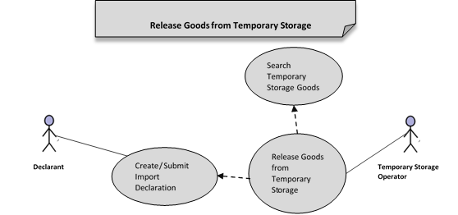

Business Validation

S/N | Validation Rules
1 | The temporary storage officer can only release goods that have been admitted in the temporary storage assigned to the officer.

Note/s:
- Declarations are created using the relevant manifest in case the specific manifest is admitted into temporary storage that declaration will be released from temporary storage after the “Release Cargo” process.

If submitted master AWB (10 Qty) must split into 2 House AWB (7 Qty and 3 Qty). Then we recommend splitting the master AWL into 2 as house manifest and then request to submit House AWB to admit into temporary storage as two separate requests i.e. 7 Qty and 3 Qty. This will allow declarant to submit declaration to the corresponding House AWB and release accordingly.

Entry manifest quantity and import declaration quantity must be equal and 1 manifest must have 1 declaration only.

Additionally, consolidated AWB cannot be submitted for Temporary Storage admission.

Appendix A

Configuration blueprint (CBP)
Configuration Blueprint (CBP) for Manifest:

Configuration Blueprint (CBP) for Temporary Storage:

Air Manifest Upload files
IATA Specification for Air Manifest:

Sample FFM (Master Manifest) File:
Sample FWB (Additional Manifest) File:
Sample FHL (House Manifest) File:

Passenger manifest Integration file template
Passenger manifest integration File:

Manifest Printouts
Air Manifest Printout:

Road Manifest Printout:

Note : Road manifest will be printed in 2 pages as we have many fields.

Passenger Manifest Printout:

Temporary Storage Tracking Details
Inventory Report:

Dispatch Challan Printout
Dispatch Challan:

Note : Dispatch challan will be printed in 2 pages as we have many fields.

Scheduler Jobs
Job Name | Running Interval | Remarks
Auto-Cancel AWB | Everyday | Cancel AWB if 30 days (configurable) after Estimated Time of Arrival:  - it is not in Temporary Storage  - it is not in a declaration
Auto-Cancel Road Manifest | Everyday | Cancel Road manifest if 30 days (configurable) after Estimated Time of Arrival, if it has no Gate-In Reference Number and is not linked to a Declaration

User Interface
Please refer to the prototype.

Note: Though we released the prototype, actual UI implementation look-and-feel may vary based on SmartGWT framework.

